2019

Nischal Tripathi

Batch 23 L5DC

12/10/2019

Train ticket booking system

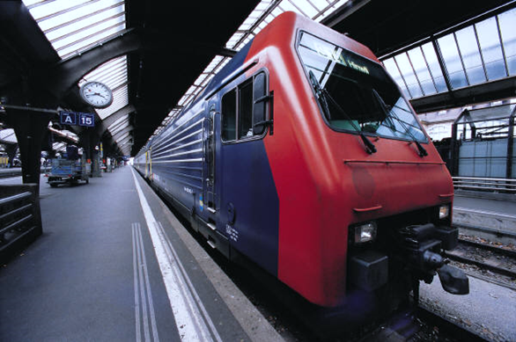

Sudeep Lal Bajimaya

NCC ID: 00176300

Submitted To

Submitted By

# Acknowledgement

While doing this project I have been experienced in many things which I even didn’t knew in the past days but mainly it’s my pleasure to make this report after completing the project on Train ticket booking system.

I am really thankful to our respected sir Mr. Sudeep lal bajimaya sir for his guidance which has lead me to completing the project. I would also like to thank my other teachers who has helps me and gave the guidance for ever elements in this project. And also I want to thanks my friends for working together and helping each other.

# Abstract

Royal services is a small train services in reading, Berkshire. Booking train has been hard to the customers because they wold require to go to the station and buy the tickets respectively. So, royal services has also started its train ticket booking system which helps the customer save their time. Not only it benefits the customers but also it benefits the employees because half of their work has been digitalized. Also it wouldn’t be possible to develop such a great system without the collaboration of royal services team. The research for development start from meetings, interviews, questionnaire etc. to know what all the employees and the customers want in the system.

Royal services is a train services company which is now giving their services online. In their online system there the customer can book, pay and also can cancel booking with one click. The information’s of the booking can also be reviewed by the admin in their own dashboard.

This system will help to do the bookings in easier way and also will make the staff work easier than before it will make sure that none of the bookings would be miss out because every bookings can be seen in the system database. Waterfall model is used to develop this application. Activity diagram, use case, class diagrams are made to make the system functionalities clear. This system is made by PHP using object oriented.

Table of Contents

Acknowledgement 1

Abstract 1

Table of figures 4

Chapter 1 4

1.1 Introduction 5

1.2 Background 5

1.3 Overview of the project 5

1.4 Justification of project 5

1.5 Aims and objectives 5

Aims 5

Objectives 6

Chapter 2 6

2.1 Analysis 6

2.2 Analysis methodology 7

2.3 Information gathering methodology 8

2.3.1 Questionnaire 8

2.4 Feasibility study 10

2.5 Software Requirement Specification (SRS) 11

2.6 Use case Diagram 17

2.7 System architecture 18

2.8 19

2.8.1 Scenario 19

2.8.2 NLA 19

2.9 Class Diagram 23

Chapter 3 24

3.1 Design 24

3.2 Structural Modelling 24

3.1.1 Final Class diagram 24

3.1.2 Optional 24

3.3 Behaviour modelling 27

3.3.1 Activity Diagram 27

3.3.2 Sequence Diagram 31

3.4 Data Modelling 34

3.4.1 Data Dictionary 34

3.4.2 ER Diagram 36

3.5 UI Modelling 37

Chapter 4: Implementation 44

4.1 Programming language used 44

4.2 Framework 44

4.3 Codes 44

Chapter 5: Testing 47

Chapter 6: Other project issues 66

6.1 Limitation 66

6.2 Future work 66

6.3 Risk management 66

6.4 Configuration management 69

6.5 Other project issues 70

6.6 User manual 71

# Table of figures

Figure 1: User DFD 7

Figure 2: Admin DFD 8

Figure 3: Use case diagram 17

Figure 4: System Architecture 19

Figure 5: Initial Class Diagram 23

Figure 6: Flow chart 26

Figure 7: System admin activity 28

Figure 8: System user login activity 29

Figure 9: system user activity 30

Figure 10: Sequence diagram of system admin 32

Figure 11: Sequence of system user 33

Figure 12: ER diagram 36

Figure 13: Home page 37

Figure 14: About page 38

Figure 15: Train schedule 38

Figure 16: Gallery 39

Figure 17: Contact 39

Figure 18: Login Admin 40

Figure 19: Login User 40

Figure 20: Register user 41

Figure 21: view train 41

Figure 22: Admin booking 42

Figure 23: Admin train 42

Figure 24: Admin update train 43

Figure 25: Login form user 44

Figure 26: User login success message 45

Figure 27: Login form code user 45

Figure 28: Login form code user 46

Figure 29: Login user 46

# Chapter 1

## 1.1 Introduction

Train ticket booking system is a software which helps people to book the train tickets from the internet. The system would help in saving time and make the ticketing experience much better. The user must have an account which they can create in the system to login to the system to use it functionalities and can also delete the bookings and buy the tickets online from a secure payment gateway.

## 1.2 Background

Royal services has been running in UK for more than a decade and they don’t had any system in which the traveller can book tickets or pay online. They had a card which can also called train card which can pay the fare but can’t pay online. To keep the database secure was a challenging by then and also to provide each and every travellers tickets manually was a disaster back then. The staffs had to work hard to do their work properly, there were no guidance back then. But now the train ticket booking system will help to do the things like online payment, online ticketing which they couldn’t do in the past.

## 1.3 Overview of the project

Train ticket booking system is an online ticketing system where you can book train tickets and pay as your requirements. Similarly, we have implemented many features to this system which are as follows,

* It can be assessable from anywhere where internet is present.
* Anyone can create their account to use the system.
* It can be assessable in any devices.
* It is the fasted way of ticketing with great user experience.

## 1.4 Justification of project

Thus this is the technical era and everyone has their own gadgets which supports internet like smart phones, tablet, laptop etc. in which the users can run this project from. Likewise this project is made using PHP using object oriented. I have make the ticket booking experience more unique and will also help in business growth.

## 1.5 Aims and objectives

## Aims

* To design a web based train ticket booking system which helps to make the reservation and the payment through the system.
* To develop a system which maintains the customer’s data security.
* To develop a system which will provide the customers great user experience while booking tickets.

## Objectives

* Customer can check the train details and its availability.
* Customer can register / login to the system.
* Customer can make changes to their bookings.
* Customer can book tickets along with their travel class.
* Customer can cancel the bookings.
* Customer can give ratings as well as their feedbacks regarding the service.
* Customer can pay online through their card.
* Admin can reschedule the time of the train.
* Admin can edit, update and delete train records.

# Chapter 2

## 2.1 Analysis

Analysis is the process of collecting the facts, identifying the problems, threats and many more. I t is basically done to study the system and its elements to identify objects of the system. It is also known as problem solving technique which helps in ensuring threat the system is working properly as according to the requirements. (tutorialspoint, n.d.)  
  
While starting this project I have to do different types of researches analysis also helps to know the problems which can be high or low and also analysis helps to maintain the usability of the system.

## 2.2 Analysis methodology

For this project I have used hard methodology because it is a problem solving approach. Also, as we know hard approach can be used to develop small as well as large software so as our software is small for now and can be large in future so we have used this methodology as our analysis methodology.

USER DFD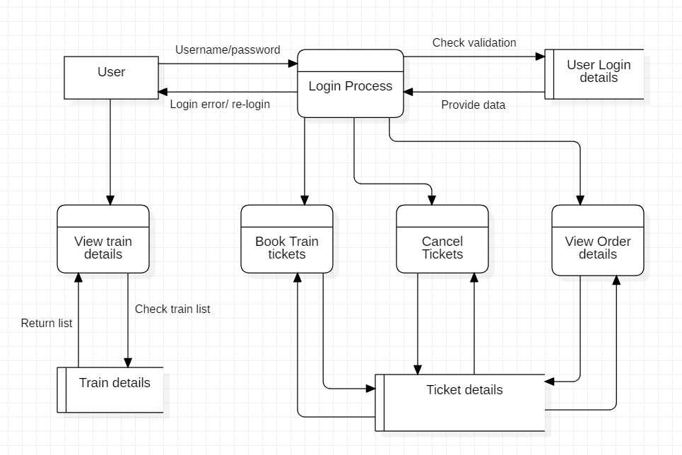

Figure 1: User DFD

Admin DFD

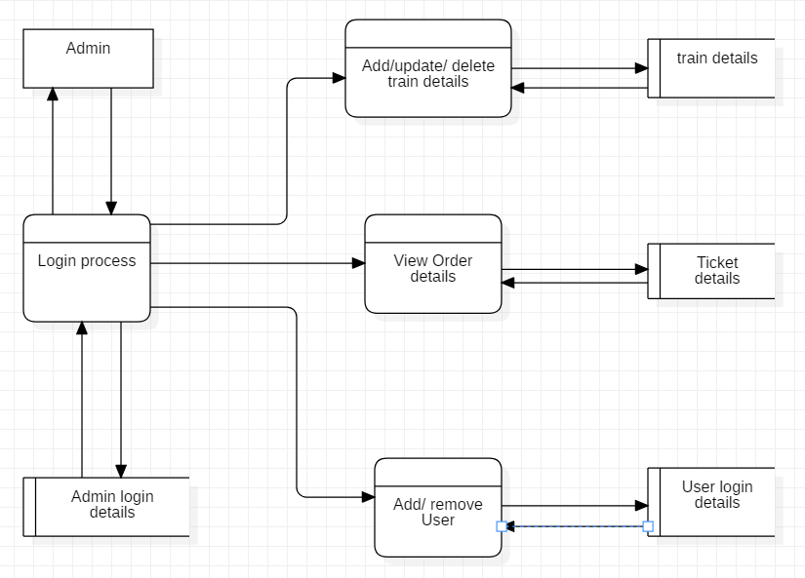

Figure 2: Admin DFD

## 2.3 Information gathering methodology

Before the developing phrase of this project I have conducted many information gathering methodology in which I have conducted questionnaire and interview with various groups of peoples. (Anon., n.d.)

### 2.3.1 Questionnaire

It is a method of research in which it consist of series of questions which is used for gathering information from the personals. For this methodology we can ask the random people about their point of views of the peoples of our circle. Below down are some answers to the questions by the peoples,

* Please rate your level of satisfaction if our software would have these functions:

|  | Very Satisfaction | Somewhat Satisfied | Neutral | Somewhat Unsatisfied | Very Unsatisfied |  |
| --- | --- | --- | --- | --- | --- | --- |
| Ease of Installation |  |  |  |  |  |  |
|  | | | | | |  |
| Required Hardware |  |  |  |  |  |  |
|  | | | | | |  |
| Smoothness in OS |  |  |  |  |  |  |
|  | | | | | |  |
| Consistency with Interface |  |  |  |  |  |  |
|  | | | | | |  |
| Easiness of using the software |  |  |  |  |  |  |
|  | | | | | |  |
| Quality |  |  |  |  |  |  |
|  | | | | | |  |
| Instructions |  |  |  |  |  |  |
|  | | | | | |  |
| It can be used from anywhere |  |  |  |  |  |  |
|  | | | | | |  |
| Customer care |  |  |  |  |  |  |
|  | | | | | |  |
| Reasonable price |  |  |  |  |  |  |
|  | | | | | |  |
|  |  |  |  |  |  |  |
|  |  |  |  |  |  |  |
|  | | | | | |  |
|  |  |  |  |  |  |  |
|  | | | | | |  |

## 2.4 Feasibility study

Feasibility study is said to be one of the important factor of development process. It shows us whether our system is cost feasible, time feasible or not. Feasibility study really plays important role on running the development process smoothly. Feasibility study also gives out that weather our project is legally, technically, economically, socially and politically fit or not. A good feasibility study gives out the strength and weaknesses of the project before it is budgeted. By doing the feasibility study companies can save money due to low defects on the system. Below are some feasibility studies,  (KENTON, 2019)

1. Economic Feasibility: Economic feasibility test is a method of getting the financial data or it is also called cost/benefit analysis methodology. It also results whether the software is in the budget or not.

Likewise, this system would be economically feasible because we do have budget which was provided by client and we would be finishing the project at its deadline so we won’t get problem economically.

1. Legal Feasibility: This is the method which watches out for the legal issues for the software. It keep tracks of the rules and regulations which the government has provided for the development and also sees weather the system has maintained its legal boundaries or not.

For, Legal feasible we have already hired a lawyer who would be looking after the rules and legal things which would help out management system to be legally feasible.

1. Technical Feasibility: This processes sees that if the company has the technical resources like hardware of the developers or not. This process also evaluate those technical resources.

To make this system we already have gadgets which are required and we don’t require to buy any other extra gadgets so technically we won’t be getting and problems.

1. Social Feasibility: This study shows the social impact towards the society by the software. It helps to analysis whether the system is feasible for the society or not. It also make sure that none of the people of the society are harmed by the system.

As, we are making a system for the society we have taken all the people’s opinions and reviews regarding the system so it would be social feasible.

1. Political Feasibility: In this process we can analysis the negative impact which can be occur by different political parties in the development phrase or afterwards.

Similarly, we would be preventing any promotions of parties or demotion of parties so that we won’t get any problems from that. So, this system is politically feasible.

## 2.5 Software Requirement Specification (SRS)

SRS also known as Software requirement specification which describes the behaviour of software. SRS fully describes what the system does and how are the expected functionalities. SRS minimize the time and effort taken by the developers for the particular project.  (Riuse, 2019)

Below down are the types of requirements required for development process,

1. Functional Requirement

Functional requirement shows the documents and activities which a system must do. All the functionalities must be cleared before the software deployment process. So, I have used different information gathering methodologies to collect the requirement accordingly the point of view of individuals. Below down are the functional requirement:

|  |  |  |  |  |
| --- | --- | --- | --- | --- |
| **Id** | **Title** | **Description** | **Rational** | **Dependency** |
| F1 | Sign Up | User can create their account | For the propose of creating a new account for further use of system | N/A |
| F2 | Login | User can be able to login. | For the propose of using the system overall. | F1 |
| F3 | View Train details | Admin and users can view the details of the train. | To view the all the details like cost, arrival, departure etc. | F1, F2 |
| F4 | Add personal record | User should be Users can add their records (details). | To add personal details. | F2 |
| F5 | Admin Login | Admin should be able to logged. | To login to get access to the admin dashboard. | N/A |
| F6 | Generate invoice | User should get an invoice. | To generate invoice after booking. | F5, F10 |
| F7 | Add train details | Admin should be able to add the train details. | To add the schedules of the train and the availability of tickets. | F5 |
| F8 | Delete train details | Admin can delete the train schedules. | To delete the train schedules. | F5, F7 |
| F9 | Update train details | Admin can update the details of the train. | To update the train details like arrival time, departure time, bookings etc. | F5, F7 |
| F10 | Ticket Booking | User can book tickets. | To book train ticket. | F3, F2 |
| F11 | View ticket order | Admin must be able to view the order details. | To view the ticket order details. | F5, F10 |
| F12 | Cancel ticket | After booking the ticket user should also be able to cancel the ticket. | To cancel ticket order. | F2 |
| F13 | Send and receive feedback | User should be able to send their feedback about the system and both admin view the message. | To send and receive feedback. | F1, F2, F5 |
| F14 | Sending notification. | Notification is a means of communication. Admin should be able to send any notice or news to the user about the system. | To send notification to the user. | F5 |
| F15 | Check booking history | User should be able to view their train booking history. | To check their train reservation history. | F2, F10 |

1. Non-functional requirements

Non-functional requirements show how a system should behave and keep its limitations of its functionality. Non- functional requirements is also known as system quality attribute’s. Below down are some non-functional requirements,

|  |  |  |
| --- | --- | --- |
| **Id** | **Title** | **Description** |
| NF1 | Security | The system should be secure only the authorized users should be able to use the system. |
| NF2 | User Friendly | System should be user friendly so the user could get great experience using the system and this may result in satisfaction of user. |
| NF3 | Performance | Good performance is necessary in order to get the output in real-time speed. There should not be any kind of delay while running the system. |
| NF4 | Reliability | It should be trust worthy so that each and every users may feel secure while using it. |
| NF5 | Maintainability | To maintain the system is the most important factor because errors may occur at any time so the system must be maintainable. |
| NF6 | Scalability | The data store in the system will increase in course of time so, the system must be always ready to change or add new features to manage the data. So the system must have scalability as it handles the amount of growing data in the system. |
| NF7 | Usability | Everyone from each and every background should be able to use this system. |
| NF8 | Serviceability(Supportability) | The system should provide support to handles the errors and the work of the user. It must give good services to the user to improve the business and user performance. |
| NF9 | Availability | The system should be available from anywhere at any time so the users may get full service of the system. |

1. MoSCoW Prioritization

|  |  |  |  |
| --- | --- | --- | --- |
| **Id** | **Requirement** | **MoSCoW** | **Rational** |
| F1 | Sign Up | Must have | For the propose of creating a new account for further use of system |
| F2 | Login | Must have | For the propose of using the system overally. |
| F3 | View Train details | Must have | To view the all the details like cost, arrival, departure etc. |
| F4 | Add personal record | Must have | To add personal details. |
| F5 | Admin Login | Must have | To get access to admin dashboard. |
| F6 | Generate invoice | Won't have | To delete the records which are not needed. |
| F7 | Add train details | Must have | To add the schedules of the train and the availability of tickets. |
| F8 | Delete train details | Should have | To delete the train schedules. |
| F9 | Update train details | Should have | To update the train details like arrival time, departure time, bookings etc. |
| F10 | Ticket Booking | Must have | To book train ticket. |
| F11 | View ticket order | Must have | To view the ticket order details. |
| F12 | Cancel ticket | Must have | To cancel ticket order. |
| F13 | Send and receive feedback | Could have | To send and receive feedback. |
| F14 | Sending notification | Could have | To send notification to the user. |
| F15 | Check order history | Could have | To check their train reservation history. |
| NF1 | Security | Must have | The system should be secure only the authorized users should be able to use the system. |
| NF2 | User Friendly | Should have | System should be user friendly so the user could get great experience using the system and this may result in satisfaction of user. |
| NF3 | Performance | Must have | Good performance is necessary in order to get the output in real-time speed. There should not be any kind of delay while running the system. |
| NF4 | Reliability | Must have | It should be trust worthy so that each and every users may feel secure while using it. |
| NF5 | Maintainability | Must have | To maintain the system is the most important factor because errors may occur at any time so the system must be maintainable. |
| NF6 | Scalability | Should have | The data store in the system will increase in course of time so, the system must be always ready to change or add new features to manage the data. So the system must have scalability as it handles the amount of growing data in the system. |
| NF7 | Usability | Must have | Everyone from each and every background should be able to use this system. |
| NF7 | Serviceability(Supportability) | Must have | The system should provide support to handles the errors and the work of the user. It must give good services to the user to improve the business and user performance. |
| NF8 | Availability | Must have | The system should be available from anywhere at any time so the users may get full service of the system. |

1. Hardware requirements

Processor: Intel® Core™ i5-5200 CPU @2.20 GHZ

RAM: 4GB above

Monitor: VGA colour monitor

1. Software requirements

Operating System: Windows 7 onwards

Developing tool: PHP my admin, notepad++

Database: PHP MY ADMIN

## 2.6 Use case Diagram

Use case diagram is figure which shows the different way of using the system by the users. To build use case we would be need some special symbols like connectors, symbols etc. It also helps to collect the functionalities requirements before making the system. Below down is the use case diagram of the system,  (Anon., n.d.)

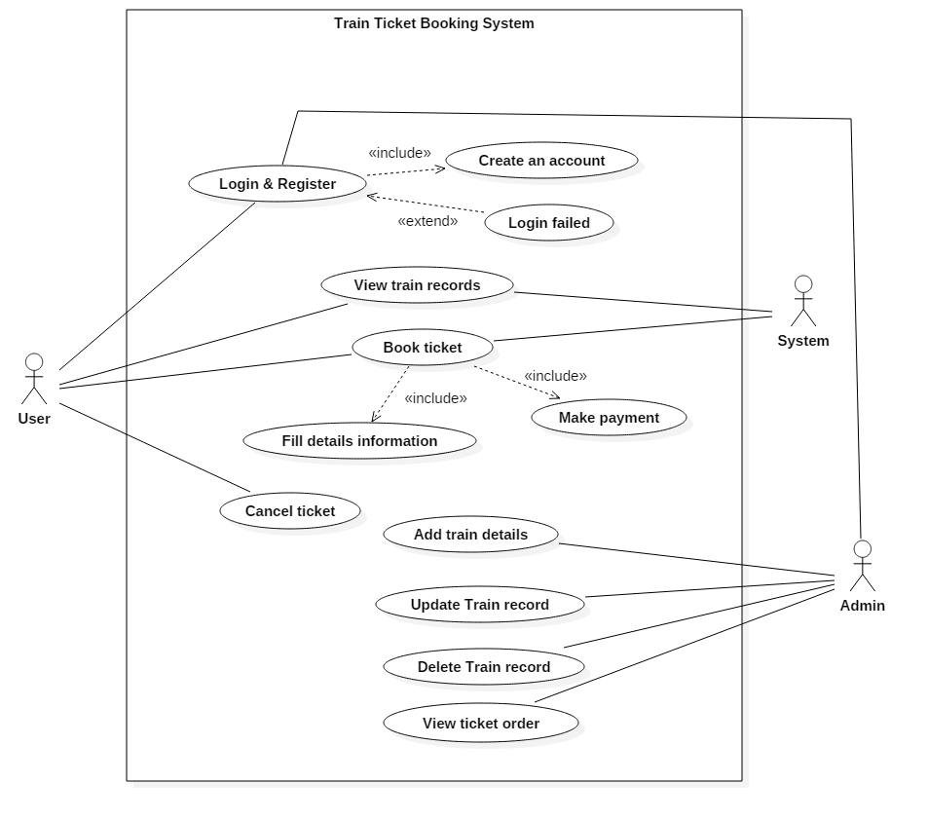

Figure 3: Use case diagram

As in the above diagram we can see there are some primary actors which are user, system and admin their work is to interact with the system. In the given figure admin are those who have the full control of the system they have authority to edit the information. Similarly, users are the one who are also known as customer or clients they have to register themselves in order to login inside the system and once they are logged in they can book tickets or make payments.

Login and register: These features are used by admin as well as user admin uses it to make any changes in the system and the user uses it to make booking and payment secure.

View train records: This functionality is used by the users to see the train’s status its price so that they can book a ticket on their feasible time.

Book ticket: The users can book the tickets after looking the feasible time period of booking and while booking they can see the train time period and they can pay.

Cancel Ticket: This feature is for the users to cancel their bookings if it’s not required any more.

Add Train details: This is the feature which the admin uses to upload the timings of arrival, ticket price and seat details of the train for the customers.

Update train records: This feature is used by the admin to change any details regarding the train.

Delete train record: This feature is used by admin to delete any train status if something went wrong in the train or in the station.

## 2.7 System architecture

System architecture that I will use in this system will be 3-tier because this is the project of client to server system so the user don’t have to use the database due to this reason I am using this method. 3-tier architecture also improves the horizontal stability, performance and availability. Below down are the three tiers.  (Anon., n.d.)

1) Presentation tier: It is a tier which is built with HTML, CSS and JavaScript and is deployed to the computer by web browsers.

2) Application tier: Application tier also known as logic tier is written in java which contains the business logic which supports the application core functionalities.

3) Data tier: It consist of database and programs for managing read and write access to a database. The database system for managing read/write access are MYSQL, Microsoft SQL Server and MangoDB.

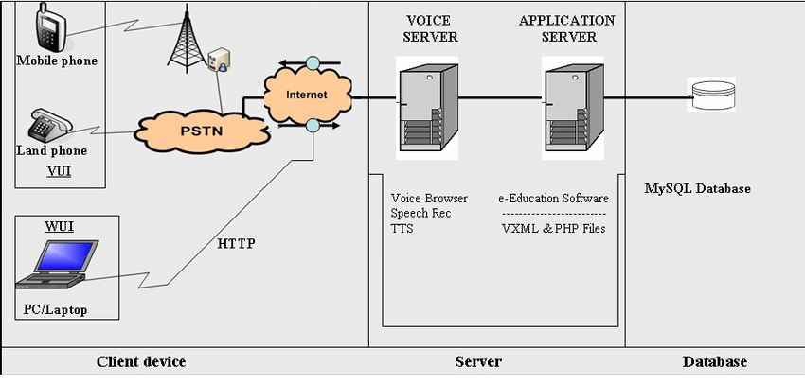

Figure 4: System Architecture

## 2.8

## 2.8.1 Scenario

Train ticket booking system is a system making the reservation process much easier for the customers. The system must include the registration, login from which passengers can make an account and book their ticket, edit or delete there reservation through online. They can also view train record by logging in to the system. This system also include the online payment methodology which makes the payment easier. This system should contain the admin panel which will be consisting the features like managing bookings, add, update and delete the status of the tickets, changing the time of arrival of train.

## 2.8.2 NLA

NLA also known as natural language analysis is a process of generating verb, noun and adjectives from the given scenario and afterwards changed it to classes, attributes and methods. For this system we have used to remove the duplications, irrelevancy.  (Garbade, 2018)

* Nouns

|  |  |  |  |
| --- | --- | --- | --- |
| Nouns | | | |
| Train | Ticket | System | System |
| Reservation | Process | Costumer | Passenger |
| Registration | Login | Customer | Account |
| Book | Ticket | Reservation | Online |
| System | Payment | System | Admin |
| Panel | Features | Bookings | Status |
| Tickets | Time | Arrival | Train record |

|  |  |  |  |
| --- | --- | --- | --- |
| Unique nouns | | | |
| Train | Ticket | System | Reservation |
| Process | Customer | Registration | Login |
| Account | Booking | Online | Admin |
| Payment | Panel | Features | Train record |
| Time | Arrival | Passenger |  |

|  |  |  |  |
| --- | --- | --- | --- |
| Irrelevant classes removed | | | |
| Customer | Ticket | System | Reservation |
| Passenger | Customer | Train record |  |
| Payment | Booking | Admin |  |

|  |  |
| --- | --- |
| Synonyms | |
| * Passenger * Customers | * Booking * Reservation |

|  |  |  |
| --- | --- | --- |
| **Noun identification for candidate class** | **Selected as candidate class** | **Justification for selection or rejection as candidate class** |
| Admin | Yes | It play significant role in the system. |
| Passenger | Yes | It play significant role in the system. |
| Payment | Yes | It specifies requirements. |
| Train records | Yes | It provides all the details information regarding train. |
| Ticket | Yes | It play significant role in the system. |
| System | Yes | Requirements specifies and act as main class in the system. |
| Booking | No | It is the method. |
| Customer | No | Alternative to passengers. |
| Train | No | Irrelevant to the requirements and it is also the property of flight list. |
| Time | No | Irrelevant to the requirements. |

|  |
| --- |
| Selected Candidate class |
| * Passengers * Ticket * Admin * System * Train records * Payment |

* Verbs

|  |  |  |  |
| --- | --- | --- | --- |
| Verbs | | | |
| Booking | Update | Include | Logging |
| Can | Make | Update | Delete |
| Include | Make | Should | Contain |
| Will | View | Consisting | Managing |
| Add | Edit | Delete | Changing |

|  |  |  |  |
| --- | --- | --- | --- |
| Unique Verbs | | | |
| Booking | Update | Include | Logging |
| Can | Make | Edit | Delete |
| Should | Contain | Will | View |
| Consisting | Managing | Add | Edit |
| Delete | Changing |  |  |

|  |  |  |
| --- | --- | --- |
| Irrelevant classes removed | | |
| Booking | Changing | Managing |
| Delete | Edit | View |
| Update | Add | Logging |

|  |
| --- |
| Synonyms |
| * Update * Edit * Changing * Managing |

|  |
| --- |
| Selected Method |
| * Add * Update * Delete * Logging * Booking * View |

## 2.9 Class Diagram

Class diagram is static structure design which shows the structure of the classes by giving out the system’s classes, their attributes, methods and relation among objects. It is helpful for business analyst to model the system for business purposes. Class diagram is also said to be the most important diagrams in UML which shows the whole system structures and components. While, this project is also been developed by being reliable on our class diagram.  (Anon., n.d.)

Accordingly the functions of each classes I have made abstract classes as well as interface.

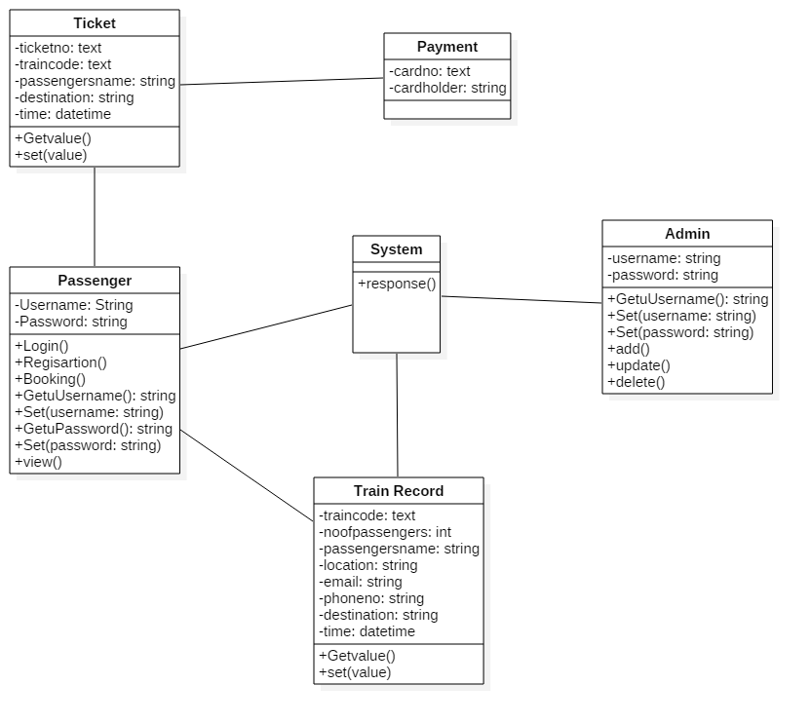

Figure 5: Initial Class Diagram

# Chapter 3

## 3.1 Design

Design is the process after analysis and also it is also known as logical and physical plan of the project. Also, Design also reduces the future risk factors in the system. It also make the system development process smooth. Design also helps in developing the structural and logical functionalities of the system.

## 3.2 Structural Modelling

### 3.1.1 Final Class diagram

Class diagram is the static design which reflects the structure of the classes by showing the system’s classes, attributes, methods as well as relation among object. It is helpful to model the system for business analyst.

* Justification

I have used the class diagram for the project I have used object oriented and in object oriented there may occur class and object so the best diagram would be class diagram. It shows us the how system’s classes interacts with one another. It helps in modelling the system.

### 3.1.2 Optional

Flow chart is a diagram which represents the process of the system. It is also known as step by step process of doing a task. Flow chart also represent the many boxes of many kinds and their work flow by connecting them by the arrows. Flow chart also plays an important role in displaying the properties of the system.

* Justification

I have used the flow chart diagram as my optional diagram because flow chart diagram helps the system to be prevented by future risk. It is also known as one the most powerful tool used in every sector for development. It has also helped me to communicate with process in a more easy way.

* Notation

|  |  |  |
| --- | --- | --- |
| Notation | Name | Explanation |
|  | Flow line | A line is a connector that shows relationship between the shapes. |
|  | Terminator | An oval represents a start or end point. |
|  | Process | A rectangle shape represents as a process. |
|  | Decision | A diamond shape indicates as a decision. |
|  | Input/output | A parallelogram represents input or output of data, as in entering data or displaying result. |
|  | On-page connector | It helps to remove or replace long or confusing lines on flowchart. |

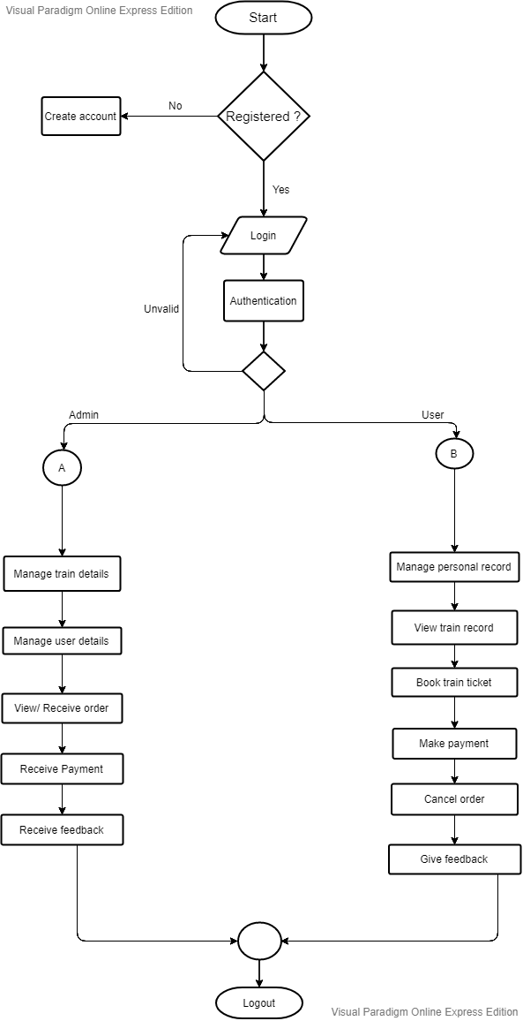

Figure 6: Flow chart

This figure represents the flow of the system. It shows us all the process of registration, login. In addition, this figure shows us what are the works of an admin in the system and what are the features which the users are getting in the system. In the simple term, this figure is showing the functionality and using methodology of the system.

## 3.3 Behaviour modelling

### 3.3.1 Activity Diagram

Activity diagram is a behaviour figure which shows the flow of activities through the system. It can also be used to show the flow of events in business process. They also been used in business to see the flow of process.  (Jain, n.d.)

* Justification

In this project I have decided to make activity diagram because it describes the sequences from one activity to other. It also describes the parallel flows of the system and gives out the flow of activates between data’s. It is also a step by step process.

* Notation

|  |  |  |
| --- | --- | --- |
| Notation | Name | Explanation |
|  | Start | Show the first phase of the workflow. |
|  | Decision | It is diamond shaped which represent a decision with different paths. |
|  | Action | It is a task to be performed. It is also represented by rectangle with round circle on sides. |
|  | Control Flow | It shows the sequences of the execution. |
|  | Activity Final Node | It is a final phase. |
|  | Sent signal | It show that the signal is being sent. |
|  | Receive signal | It shows the signal is being received. |
|  | Time event | This represents to an event that stop the flow of a time. |
|  | Note | It is used to show additional information. |
|  | Fork node | Splits the behaviour into a set of parallel or concurrent flows of activities. |
|  | Join node | Bring back together a set of a parallel or concurrent flows of activities. |

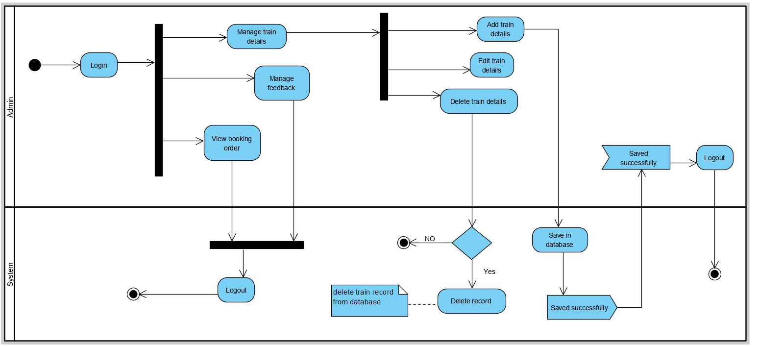

Figure 7: System admin activity

This figure shows the login method and the process of using the system by admin. So, to make some change in the system admin should be logged in to the system and afterwards they can manage bookings, manage user details, and delete the records. Admin is also able to receive the orders and see the feedbacks of the customers.

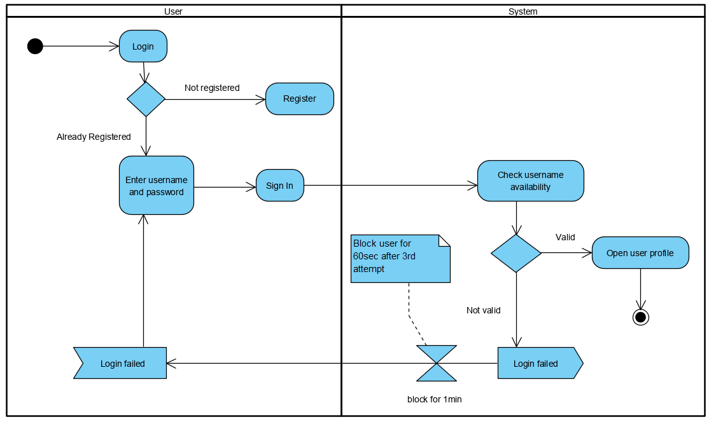

Figure 8: System user login activity

This figure shows the login activity of the user. At first phase the user is require to register themselves so that they can login to the system. While getting login if the user fail to use the right username and password until the 3rd attempt they would be block for 3 minutes.

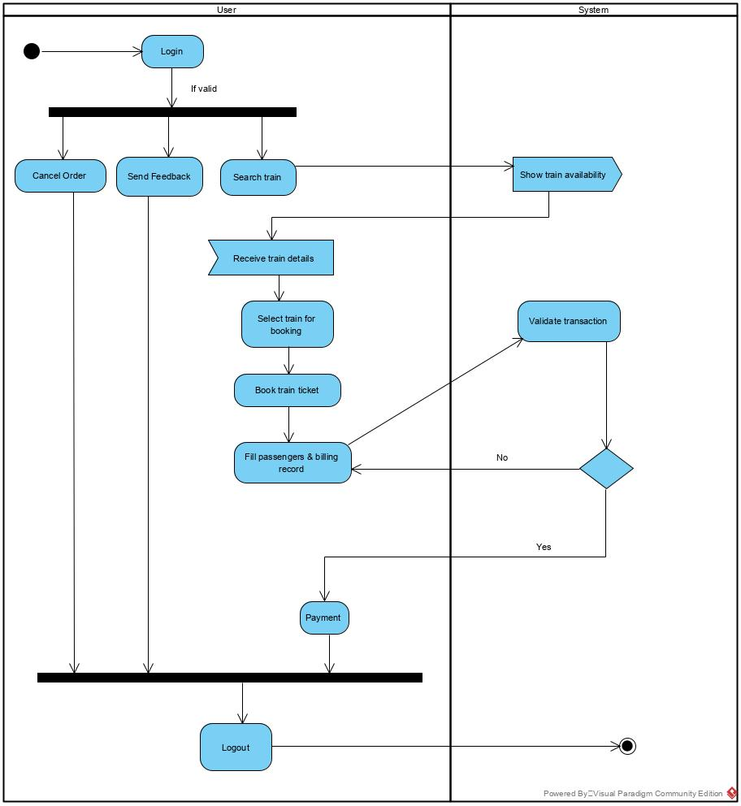

Figure 9: system user activity

This figure shows the process of using the system by the user. While users can search the train and can see their schedules also they can cancel the bookings, make payment for the tickets through the system.

### 3.3.2 Sequence Diagram

Sequence diagram is one of the UML diagram which falls under behaviour diagram. It shows how the system is worked and also is a good way to validate the runtime scenario. (Anon., n.d.)

* Justification

I have made sequence diagram because it shows the active objects in a system. It will also help us to change the behaviour of the system in the future use. It models the system accordingly the various scenario.

* Notation

|  |  |  |
| --- | --- | --- |
| Notation | Name | Explanation |
|  | Actor | Actor are the role played by the users which interact with the system. |
|  | Activation box | Activate is used to denote participation activation. |
|  | Object | They are model elements which represents the instance of the class. |
|  | Life line | It represents each instance in an interaction. |
|  | Loop symbol | It is used when the scenario occurs only under certain conditions. |
|  | Alternative symbol | It is used to represent alternatives. It is a rectangular box which consist dash line inside. |
|  | Synchronous message | It is used when sender must wait for the response to the message. |
|  | Reply message | They are the dash line with arrowhead which replies to calls. |
|  | Self-message | Self-message is a kind of message that represents the invocation of message of the same lifetime. |
|  | Note | Used to attach various remarks to elements. |

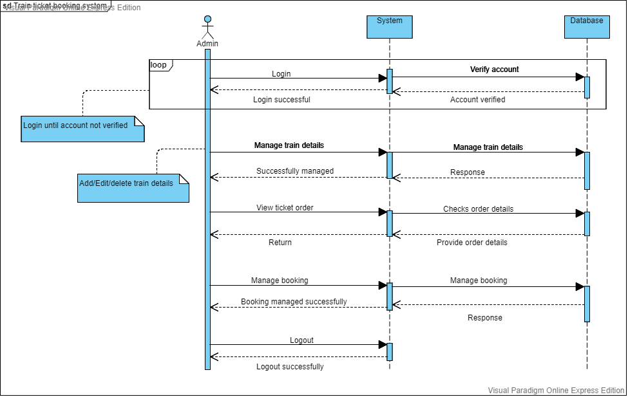

Figure 10: Sequence diagram of system admin

The given figure is the sequence diagram of system admin in which admin should be logged in to get access of all the features of the admin panel. In admin panel they can manage train details, manage user details manage bookings, response to the feedbacks and also receives the payment done by the user.

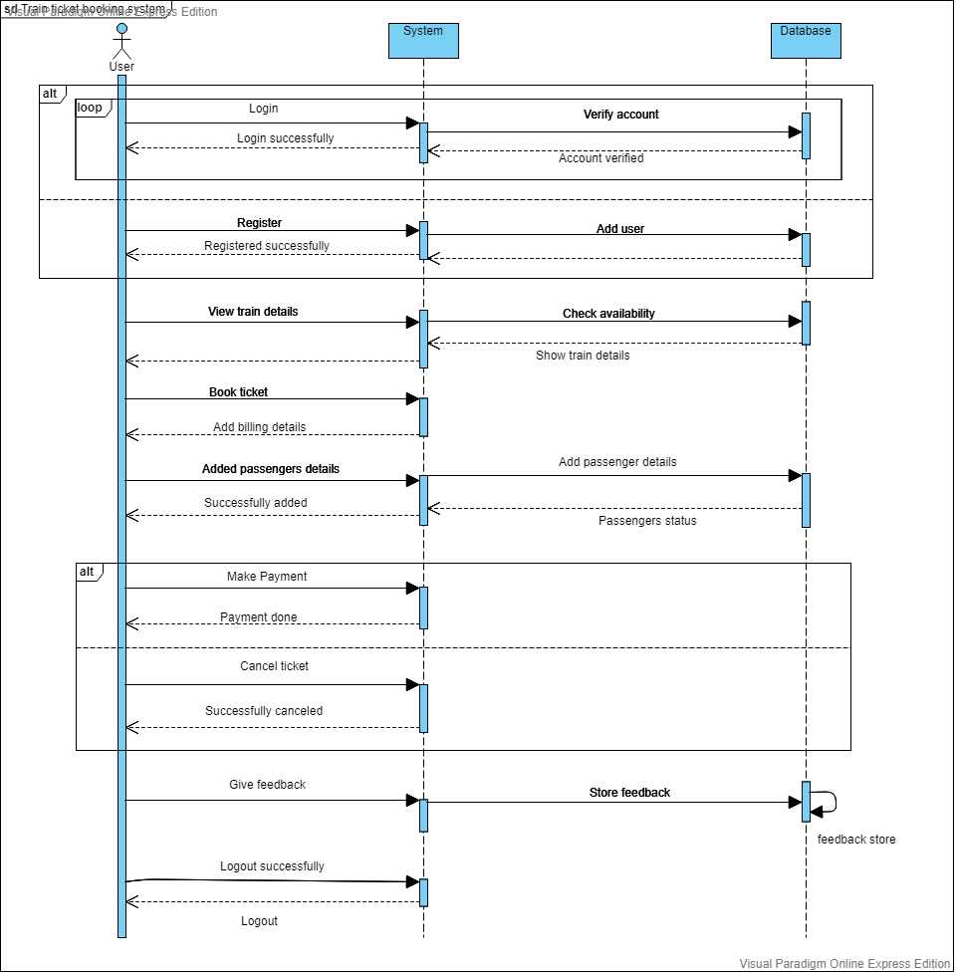

Figure 11: Sequence of system user

In the above figure of system user. The user of the system must require to get register to get access in the system and after getting access in the system they can view he train details, check the availability of the train make payment for their tickets and send the feedback to the system regarding their experiences.

## 3.4 Data Modelling

### 3.4.1 Data Dictionary

* User registration

|  |  |  |  |  |  |
| --- | --- | --- | --- | --- | --- |
| **No.** | **Attribute** | **Data Type** | **Length** | **Constraint** | **Description** |
| 1 | Reg_id | Integer | 255 | Primary key | It store registration id. |
| 2 | Username | varchar | 30 | Not Null | It store username of user. |
| 3 | Email | varchar | 50 | Not Null | It store email of user. |
| 4 | Password | varchar | 20 | Not Null | It store user password. |
| 5 | Confirm password | varchar | 20 | Not Null | It store and confirms user password. |
| 6 | Phone number | varchar | 30 | Not Null | It store user phone number. |

* User login

|  |  |  |  |  |  |
| --- | --- | --- | --- | --- | --- |
| **No.** | **Attribute** | **Data Type** | **Length** | **Constraint** | **Description** |
| 1 | Userid | Integer | 255 | Primary key | It store User id. |
| 2 | Username | varchar | 30 | Not Null | It store username of user. |
| 4 | Password | varchar | 20 | Not Null | It store user password. |

* Admin Login

|  |  |  |  |  |  |
| --- | --- | --- | --- | --- | --- |
| **No.** | **Attribute** | **Data Type** | **Length** | **Constraint** | **Description** |
| 1 | Adminid | Integer | 255 | Primary key | It store Admin id. |
| 2 | Username | varchar | 30 | Not Null | It store username of admin. |
| 3 | Password | varchar | 20 | Not Null | It store admin password. |

* Train details

|  |  |  |  |  |  |
| --- | --- | --- | --- | --- | --- |
| **No.** | **Attribute** | **Data Type** | **Length** | **Constraint** | **Description** |
| 1 | Trainid | Integer | 255 | Primary key | It store Train id. |
| 2 | Adminid | Integer | 255 | Foreign key | It comes from admin table. |
| 3 | Train_no | varchar | 30 | Not Null | It store the train number. |
| 4 | From | varchar | 30 | Not Null | It store passenger on boarding place. |
| 5 | To | varchar | 30 | Not Null | It store passenger arrival place. |
| 6 | Cost | varchar | 50 | Not Null | It stores Train ticket price. |
| 7 | Departure_time | varchar | 255 | Not Null | It store train departure time. |
| 8 | Arrival time | varchar | 255 | Not Null | It stores arrival time of train. |
| 9 | Duration | varchar | 50 | Not Null | It stores time taken to reach destination place. |
| 10 | Date | date |  | Not Null | It stores traveling date. |

* Passenger details

|  |  |  |  |  |  |
| --- | --- | --- | --- | --- | --- |
| **No.** | **Attribute** | **Data Type** | **Length** | **Constraint** | **Description** |
| 1 | Passenger_id | Integer | 255 | Primary key | It store Passengers id. |
| 2 | Trainid | Integer | 255 | Foreign key | It comes from train details. |
| 3 | Name | varchar | 50 | Not Null | It store passengers' name. |
| 4 | Address | varchar | 50 | Not Null | It store passengers address. |
| 5 | Contact No. | varchar | 30 | Not Null | It stores passengers contact number. |
| 6 | No_of_passenger | Integer | 30 | Not Null | It stores number of passenger. |
| 7 | No_of_ticket | Integer | 30 | Not Null | It store number of ticket. |

* Payment

|  |  |  |  |  |  |
| --- | --- | --- | --- | --- | --- |
| **No.** | **Attribute** | **Data Type** | **Length** | **Constraint** | **Description** |
| 1 | Payment_id | Integer |  | Primary key | It store Payment id. |
| 2 | Passenger_id | Integer |  | Foreign key | It comes from passenger table. |
| 3 | Fname | varchar | 30 | Not Null | It store card holder’s first name. |
|  | Lname | varchar | 30 | Not Null | It store card holder’s last name. |
| 4 | Postal_code | varchar | 20 | Not Null | It store postal code |
| 5 | Card_type | Varchar | 30 | Not Null | It stores card type. |
| 6 | Card_no | varchar | 100 | Not Null | It stores card number. |
| 7 | Expiry_date | date |  | Not Null | It stores expiry date of card |

* Feedback

|  |  |  |  |  |  |
| --- | --- | --- | --- | --- | --- |
| **No.** | **Attribute** | **Data Type** | **Length** | **Constraint** | **Description** |
| 1 | F_id | Integer |  | Primary key | It store User id. |
| 2 | Userid | Integer |  | Foreign key | It comes from user table. |
| 3 | Name | varchar | 20 | Not Null | It store username. |
| 4 | Date | date |  | Not Null | It stores date of given feedback. |
| 5 | Comment | varchar | 500 | Not Null | It store feedback. |

### 3.4.2 ER Diagram

It is a graphical representation of entities and their relationship to each other. It is mostly used in computing in regards to the organization of data within the databases.  (Anon., n.d.)

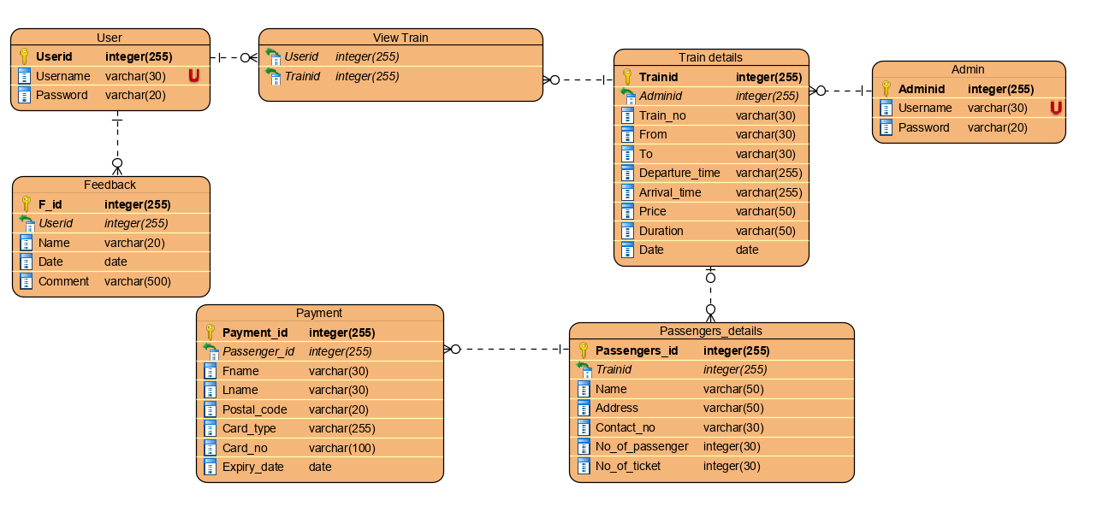

Figure 12: ER diagram

## 3.5 UI Modelling

* Home page

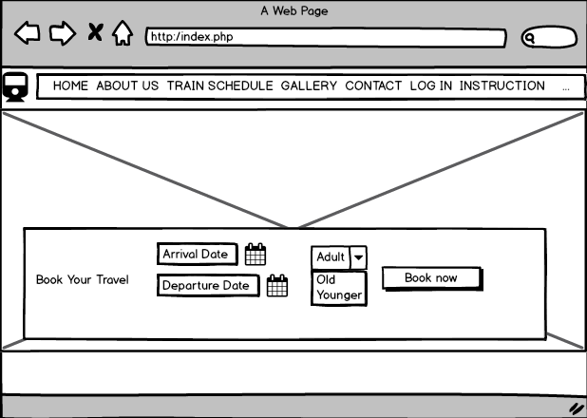

Figure 13: Home page

* About Us

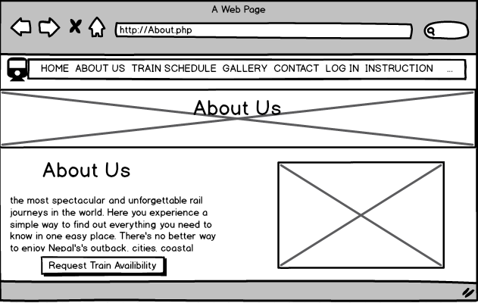

Figure 14: About page

* Train schedules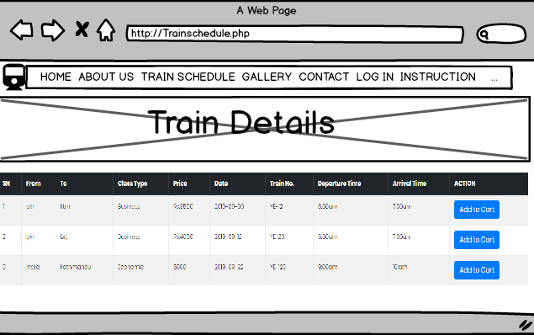

Figure 15: Train schedule

* Gallery

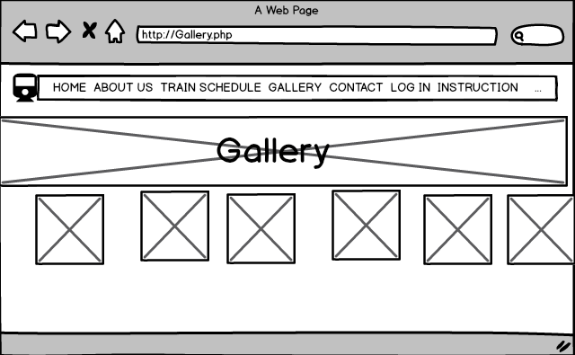

Figure 16: Gallery

* Contact

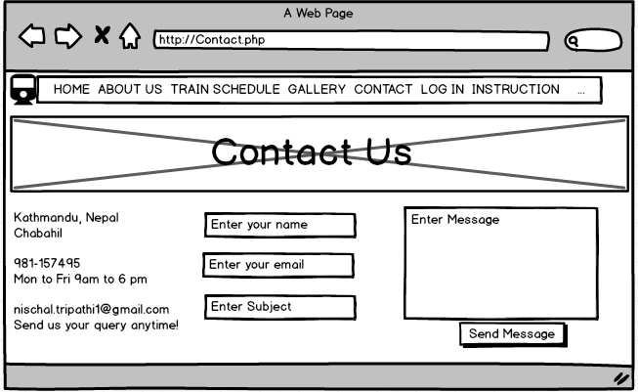

Figure 17: Contact

* Login-admin

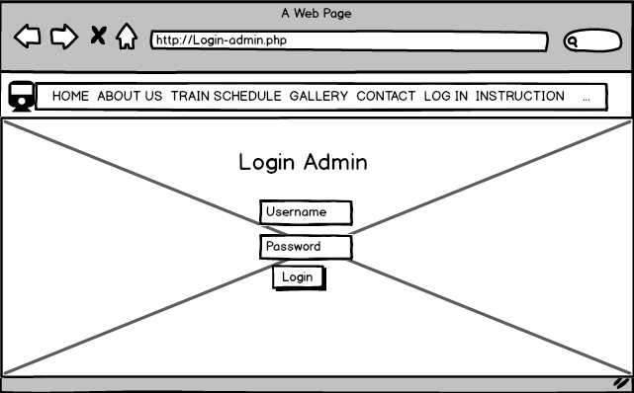

Figure 18: Login Admin

* Login-user

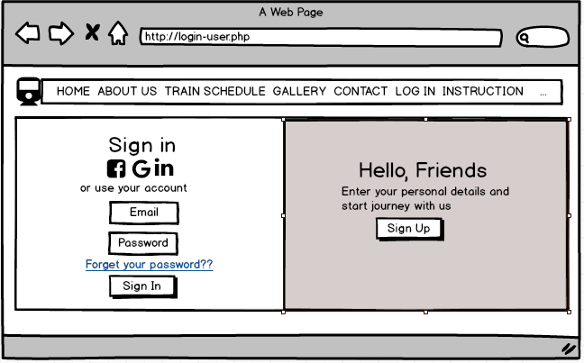

Figure 19: Login User

* Register user

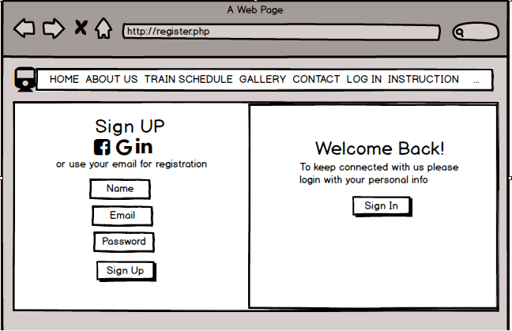

Figure 20: Register user

* View train

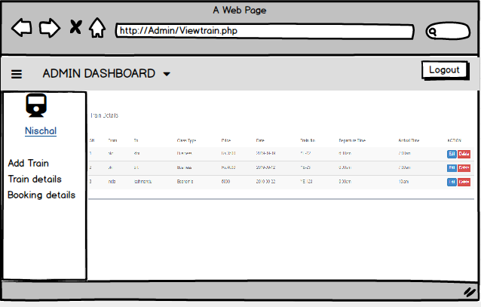

Figure 21: view train

* Bookings

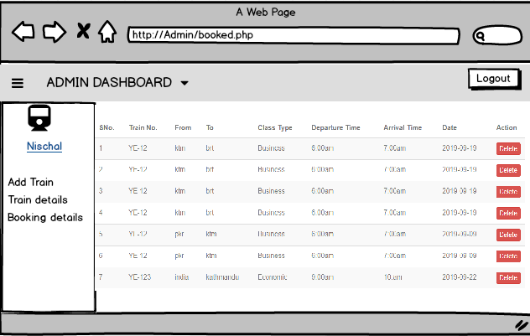

Figure 22: Admin booking

* Insert train details

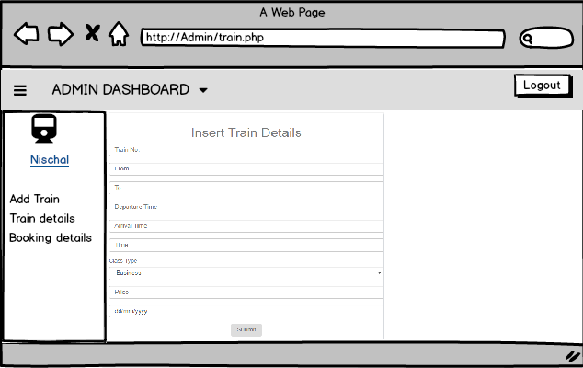

Figure 23: Admin train

* Update train

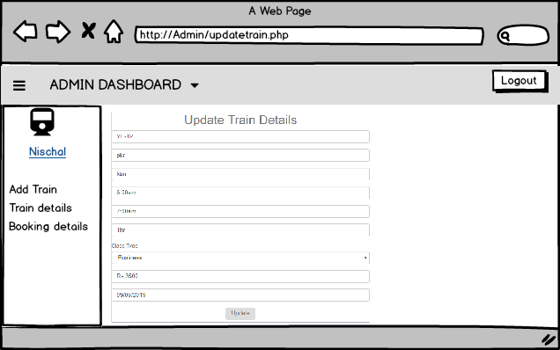

Figure 24: Admin update train

Chapter 4: Implementation

## 4.1 Programming language used

* PHP

For this project I have used PHP because it is mostly used by everyone. It best option for future maintenance of the system. PHP is also said to be the free scripting language. We can write the scripts and run it in the server. PHP is also known as server side scripting language.  (Anon., n.d.)

## 4.2 Framework

* OOP
* Object oriented is a language model which focus on data or object rather than logic and functions. Object is also known as a data field with unique attributes and behaviour. Below down are some advantages of using OOP, (Carey & Carlson, 2002)
* It is secure.
* It has better productivity.
* We can reuse codes with inheritance.

## 4.3 Codes

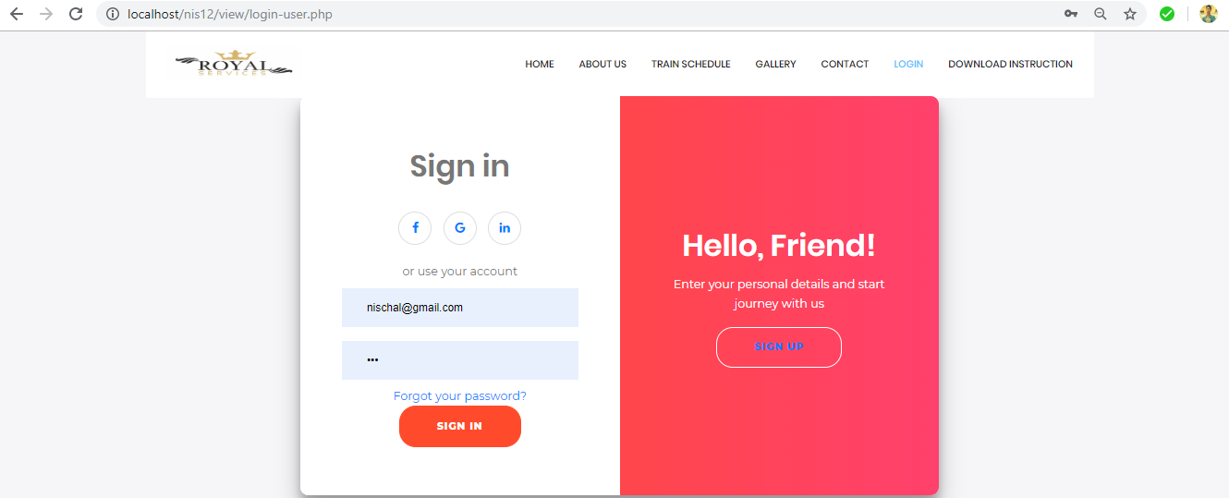

Figure 25: Login form user

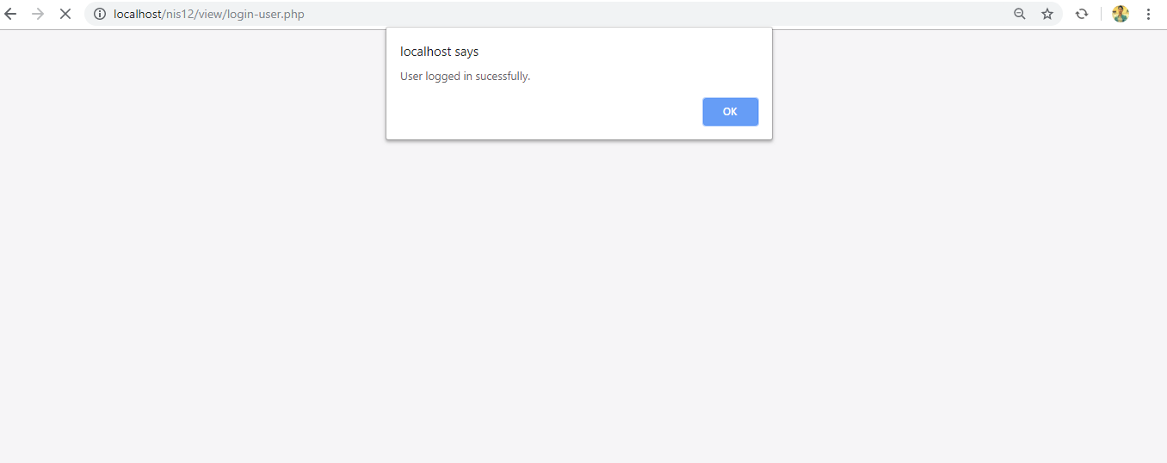

Figure 26: User login success message

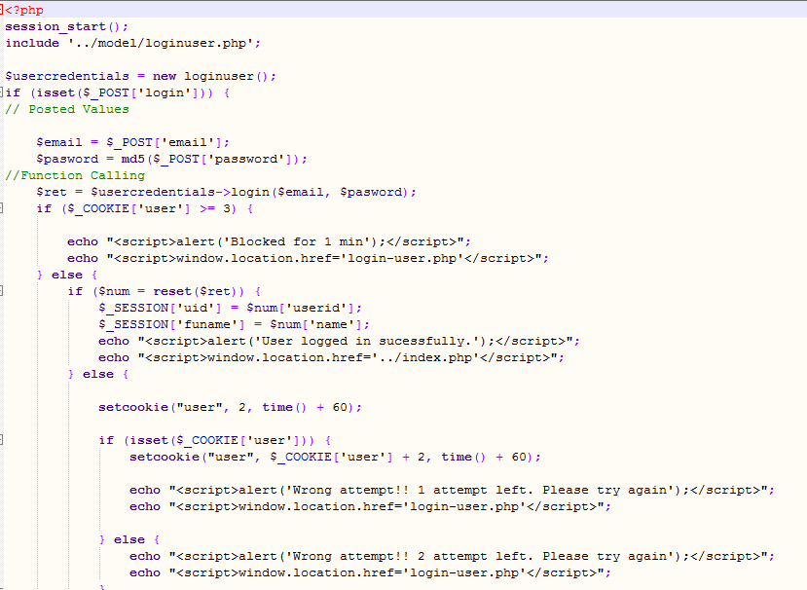

Figure 27: Login form code user

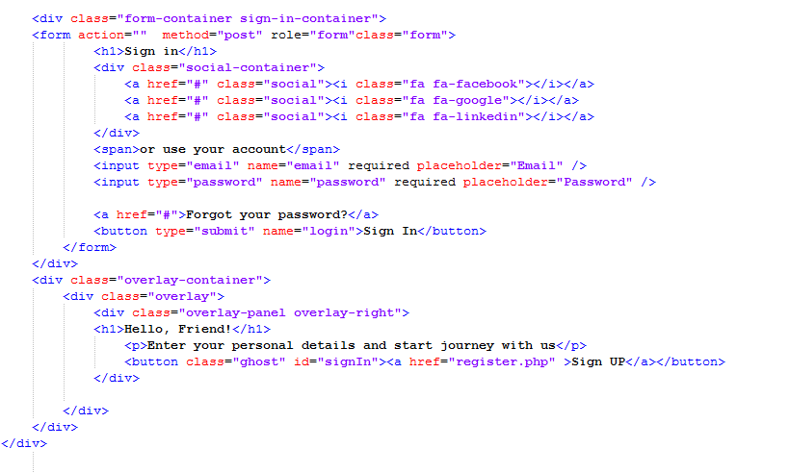

Figure 28: Login form code user

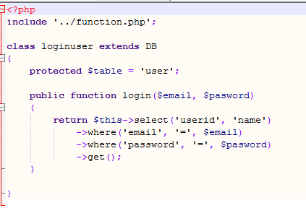

Figure 29: Login user

Hence, those were the codes of user login panel and please find the rest of the codes of the system at Appendix

# Chapter 5: Testing

System testing is a process of testing of full software. System testing makes sure that the system’s functions are working properly or not. It also helps to prevent future risks. It is done before the project is published. It can show us the error we can get while using the system and helps to deal with it.  (Anon., 2011)

For this system I have used Black Box testing due to the following reason.

* This test is done by using the point of views of users.
* This test can be immediate done after the system is completed.
* It shows the accurate result because we run the system to do this test.

Black Box testing 1: Registration and its validation

|  |  |  |  |  |  |
| --- | --- | --- | --- | --- | --- |
| Test Case | Description | Task | Expected Result | Actual Result | Conclusion |
| 1 | Register in the system. | Fill all the attributes present. | New account created for the user. | User account created successfully. | Pass |
| 2 | Validation of form. | Leave any attribute blank or incorrect email address format | Show error message to the user. | Error message was displayed to user. | Fail |

Output:

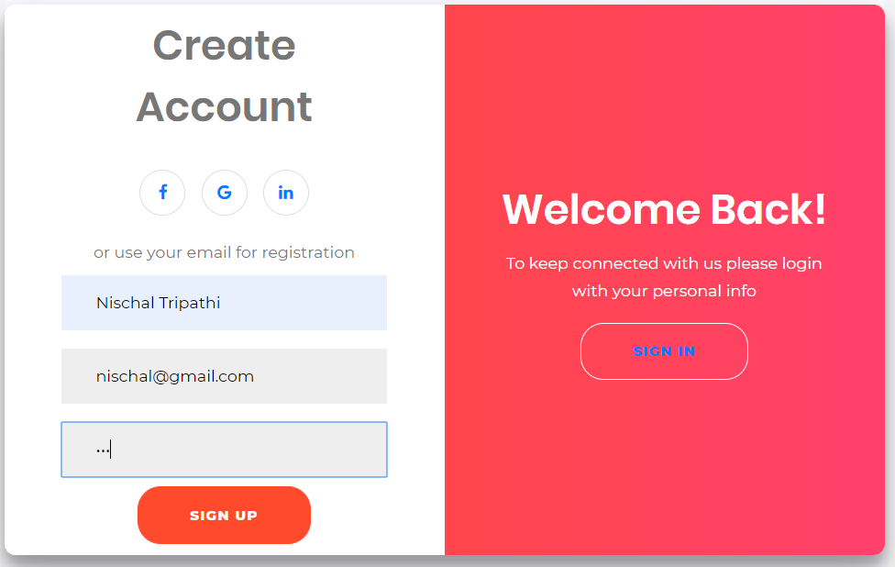

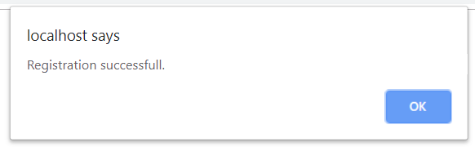

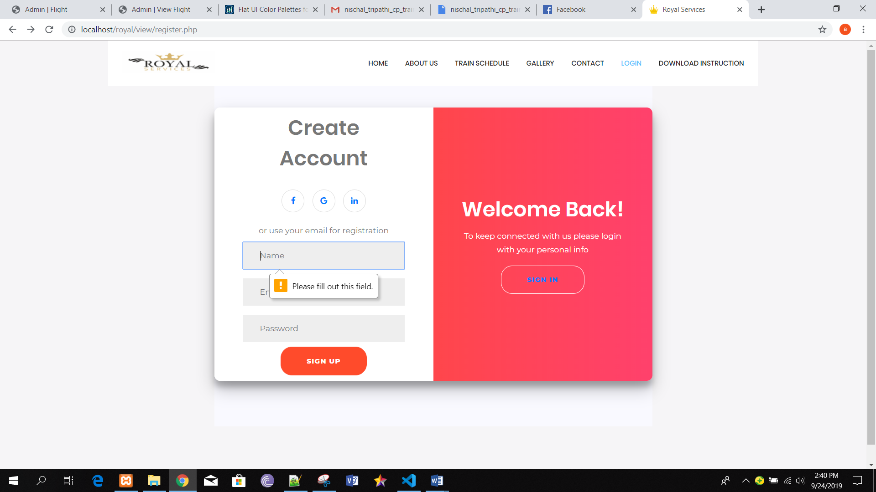

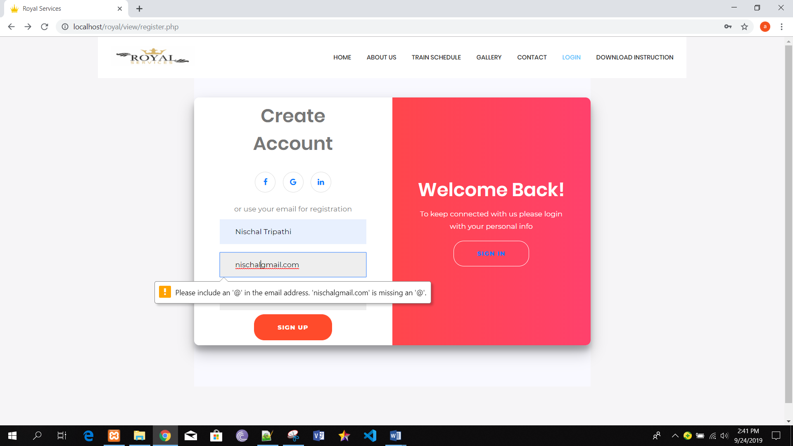

Black box test 2: Login

|  |  |  |  |  |  |
| --- | --- | --- | --- | --- | --- |
| Test Case | Description | Task | Expected Result | Actual Result | Conclusion |
| 1 | Login in the system. | Add email and password. | Login successful. | User logged in successfully. | Pass |
| 2 | Validation of form | Leave all the attribute blank. | Error message must be displayed to the user. | Error message displayed. | Fail |
| 3 | Invalid Login | Add invalid account details. | User blocked for 60 sec after 3rd attempt. | User blocked for 60 sec after 3rd attempt. | Fail |

Output:

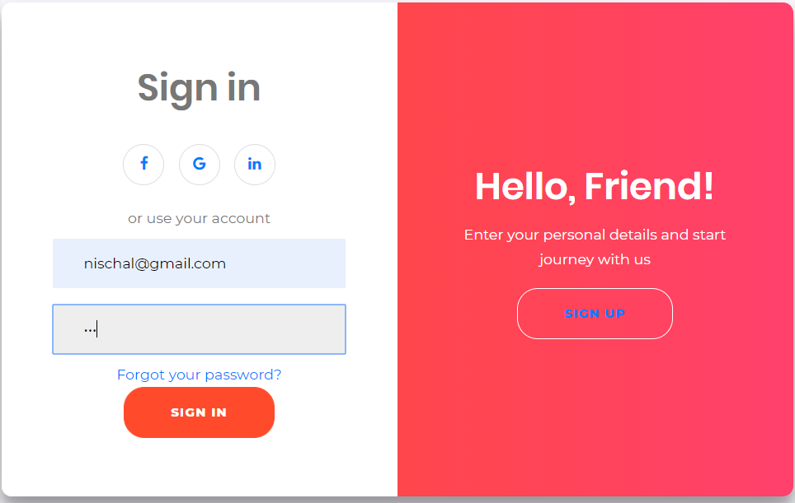

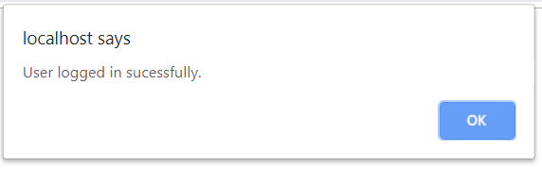

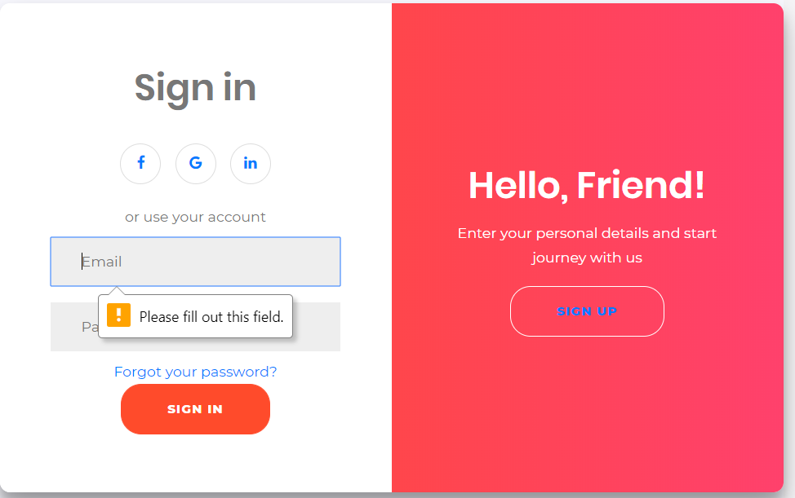

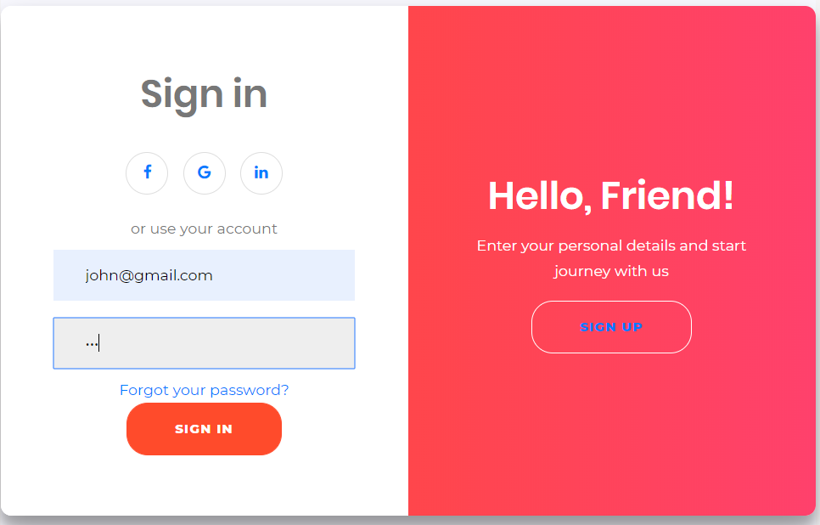

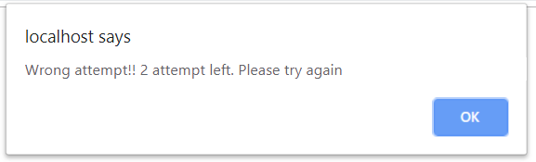

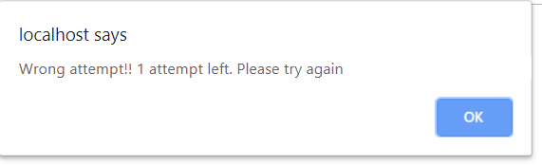

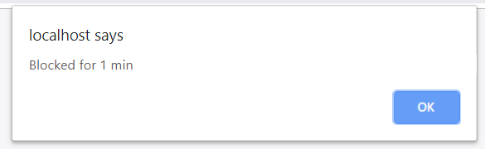

Black box testing 3: Add passenger details

|  |  |  |  |  |  |
| --- | --- | --- | --- | --- | --- |
| Test Case | Description | Task | Expected Result | Actual Result | Conclusion |
| 1 | Add passenger details. | Fill all the given attributes. | Data added successfully. | Data added successfully. | Pass |
| 2 | Form validation | Insert wrong email format. | Error message must be displayed. | Error message displayed. | Fail |

Output:

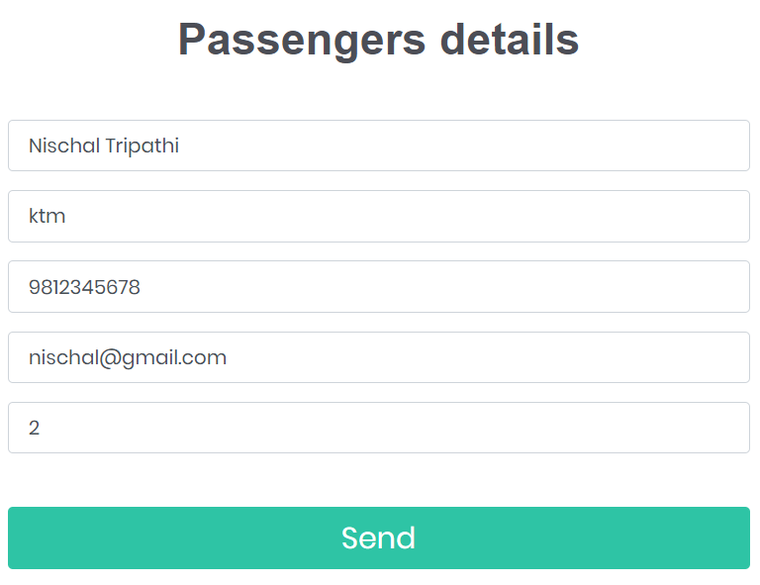

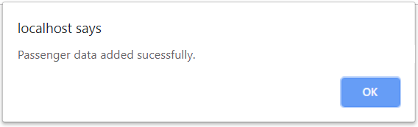

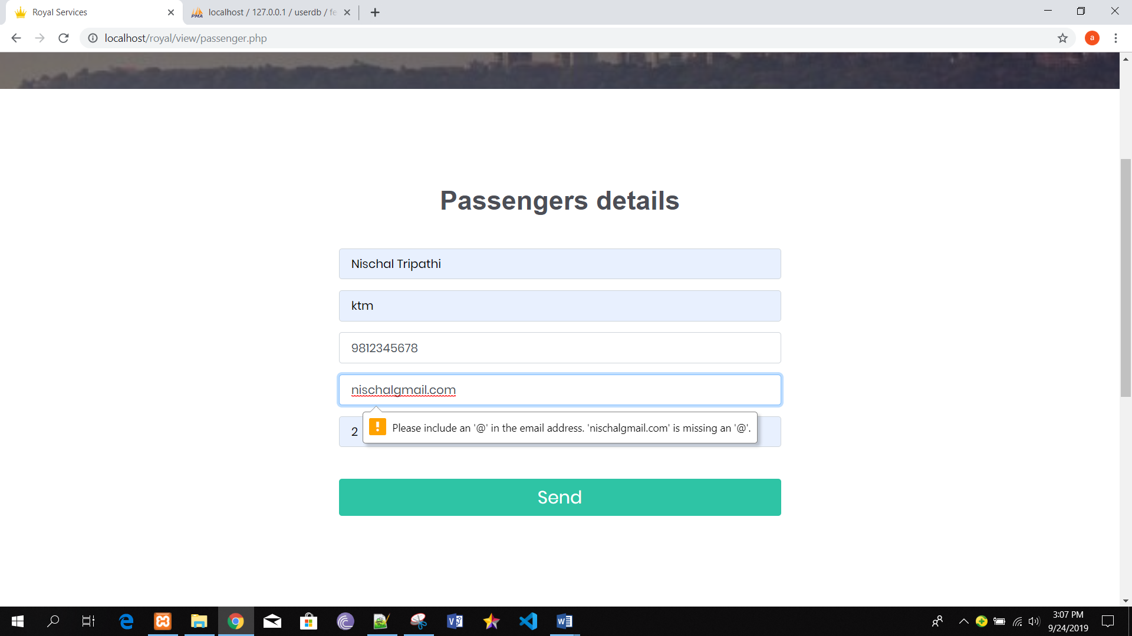

Black box testing 4: Add payment details

|  |  |  |  |  |  |
| --- | --- | --- | --- | --- | --- |
| Test Case | Description | Task | Expected Result | Actual Result | Conclusion |
| 1 | Add payment details. | Fill all the given attributes. | Payment made successfully. | Payment made successfully. | Pass |
| 2 | Form validation | Leave any attribute blank. | Give error message to user. | Error message displayed. | Fail |

Output:

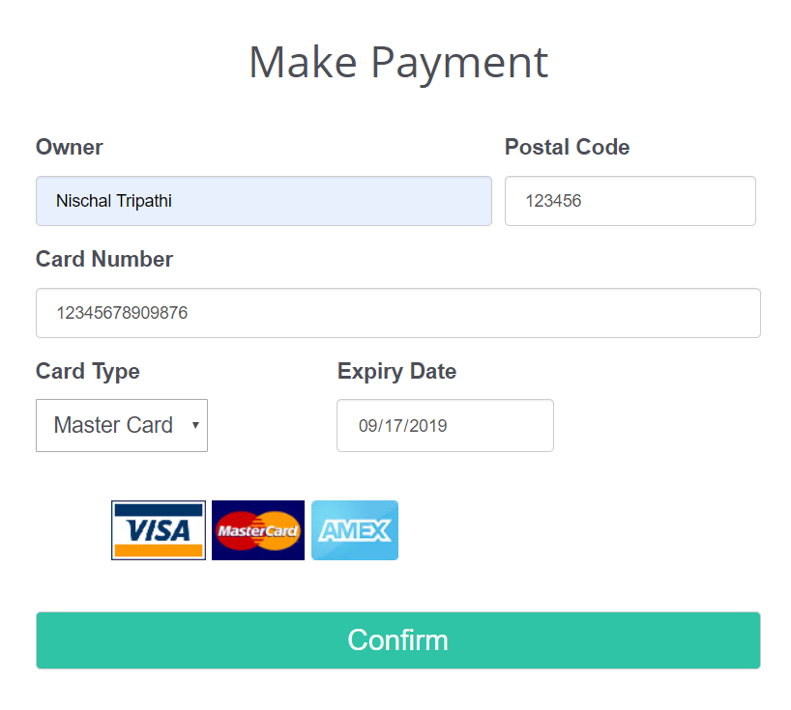

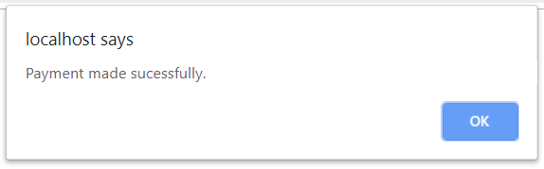

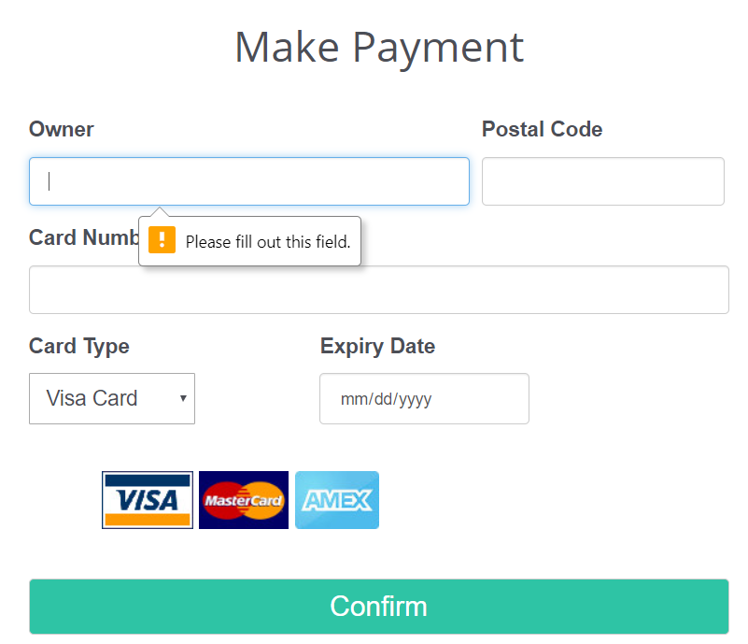

Black box testing 5: Admin Login and validation

|  |  |  |  |  |  |
| --- | --- | --- | --- | --- | --- |
| Test Case | Description | Task | Expected Result | Actual Result | Conclusion |
| 1 | Login in the system. | Add username and password. | Login successful. | User is logged in to the system successfully. | Pass |
| 2 | Invalid Login | Add invalid account details. | Username and password did not match. | Login unsuccessful. | Fail |

Output:

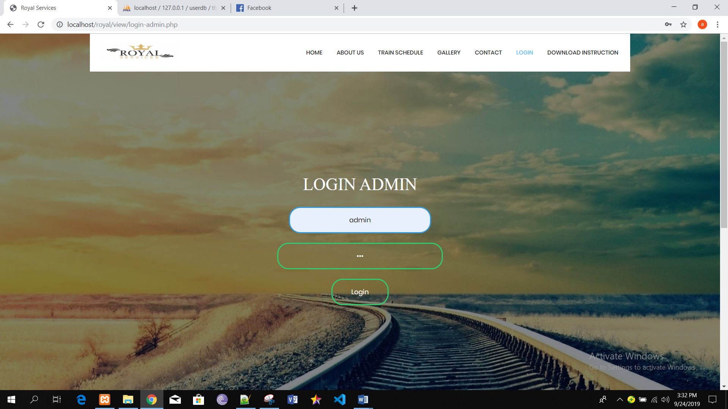

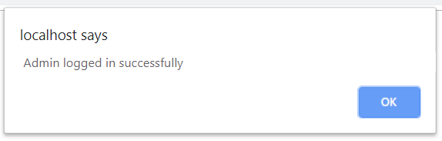

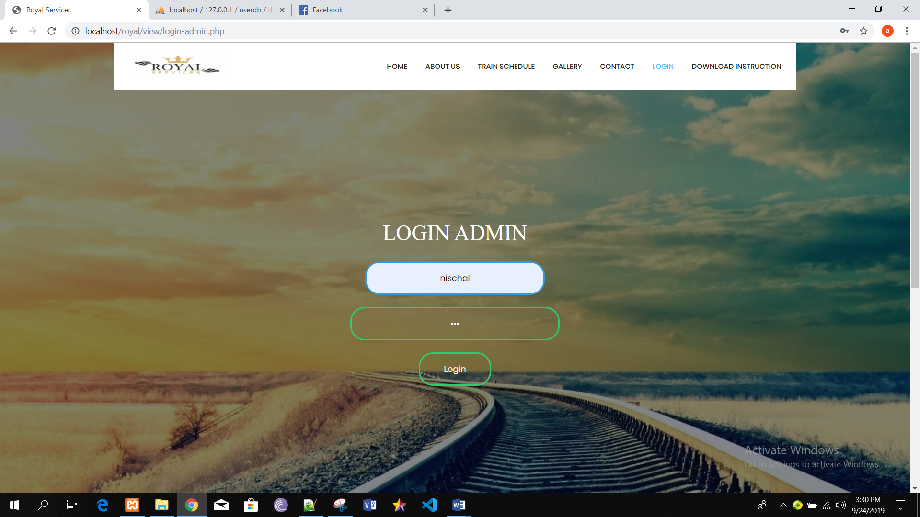

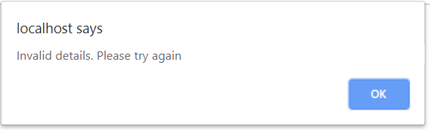

Black box testing 6: Add train details

|  |  |  |  |  |  |
| --- | --- | --- | --- | --- | --- |
| Test Case | Description | Task | Expected Result | Actual Result | Conclusion |
| 1 | Add train details | Fill all the attributes given. | Data must be added successfully. | Train details recorded successfully. | Pass |
| 2 | Validation of form | Leave all attributes blank. | Admin will get an error message of validation. | Admin get an error message. | Fail |

Output:

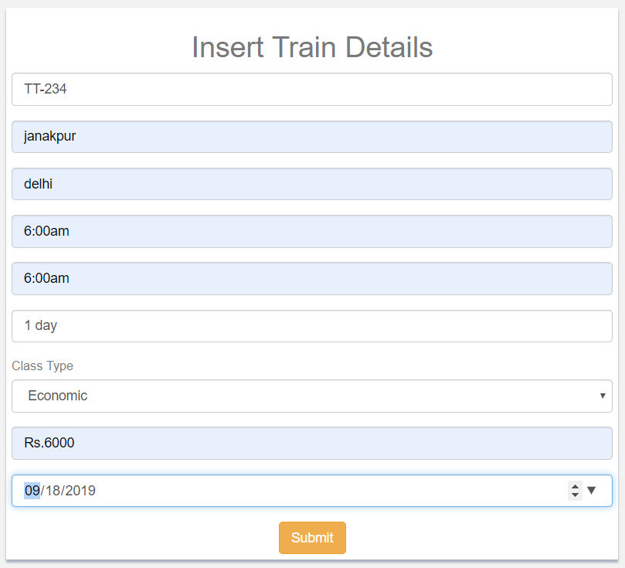

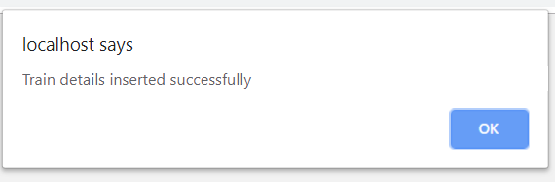

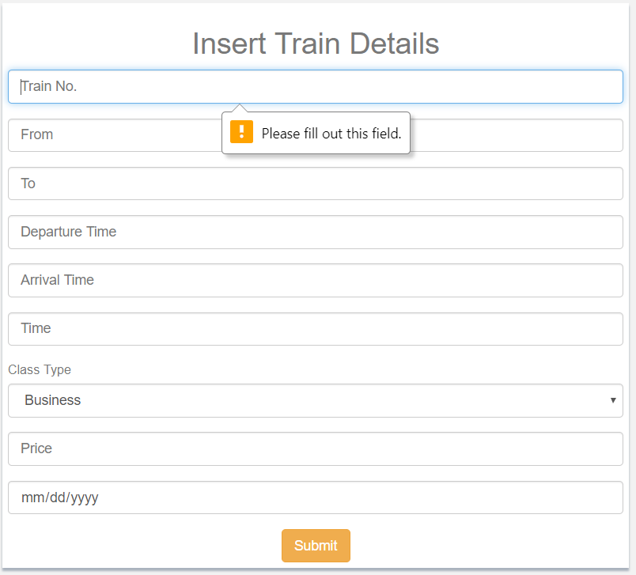

Black box testing 7: Update Train details

|  |  |  |  |  |  |
| --- | --- | --- | --- | --- | --- |
| Test Case | Description | Task | Expected Result | Actual Result | Conclusion |
| 1 | Update train details | Train data must be fetch from train details form. | Train details must be updated successfully. | Record Updated successfully. | Pass |

Output:

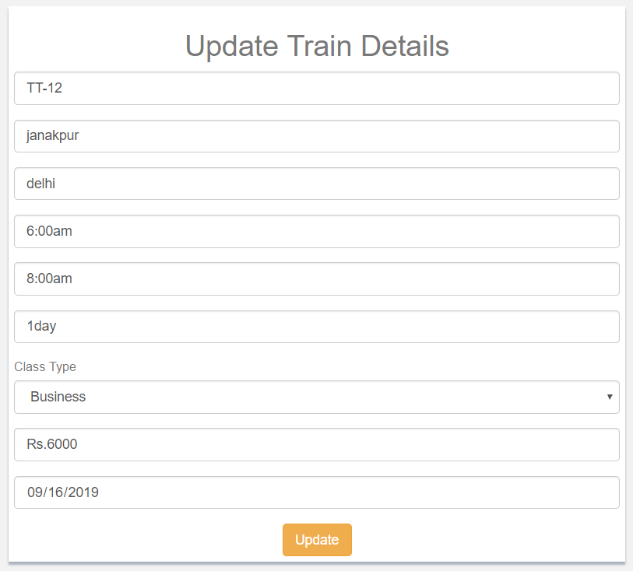

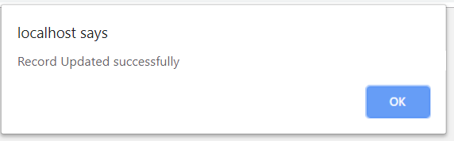

Black box testing 8: Delete train record

|  |  |  |  |  |  |
| --- | --- | --- | --- | --- | --- |
| Test Case | Description | Task | Expected Result | Actual Result | Conclusion |
| 1 | Delete train details | Admin can select the data from table and delete it. | Train record must be deleted from the table. | Record deleted successfully. | Pass |

Output:

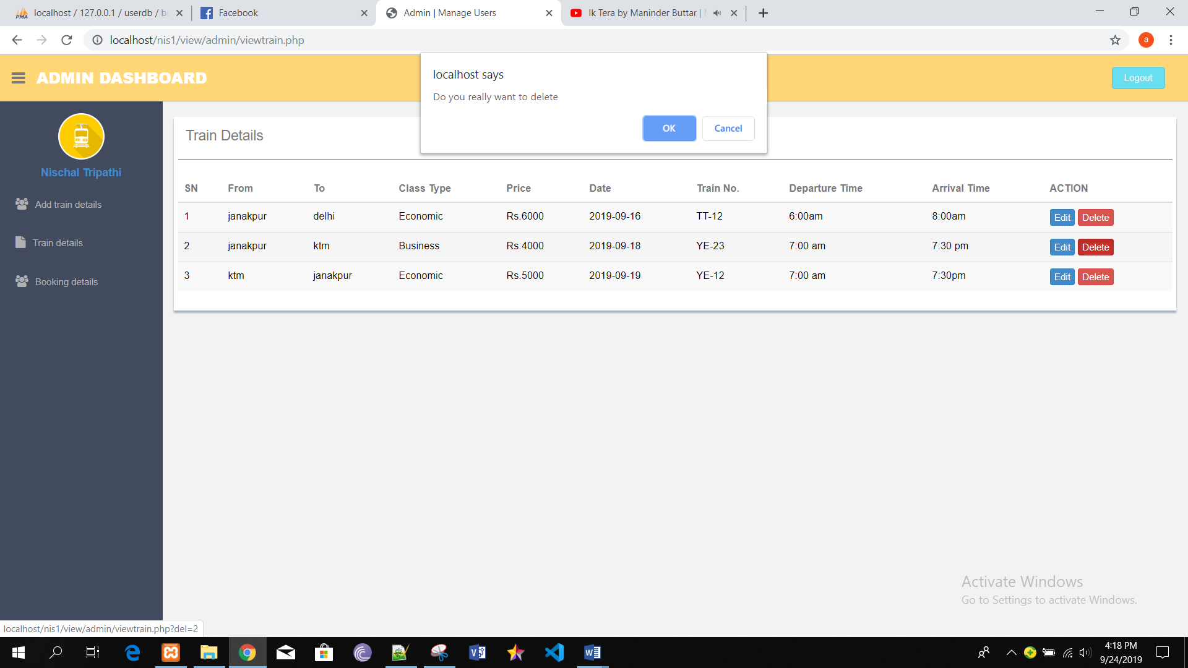

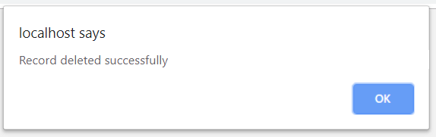

Black box testing 9: Delete Booking record

|  |  |  |  |  |  |
| --- | --- | --- | --- | --- | --- |
| Test Case | Description | Task | Expected Result | Actual Result | Conclusion |
| 1 | Delete booking details | Admin can select the data from table and delete it. | Booking details must be deleted from the table. | Record deleted successfully. | Pass |

Output:

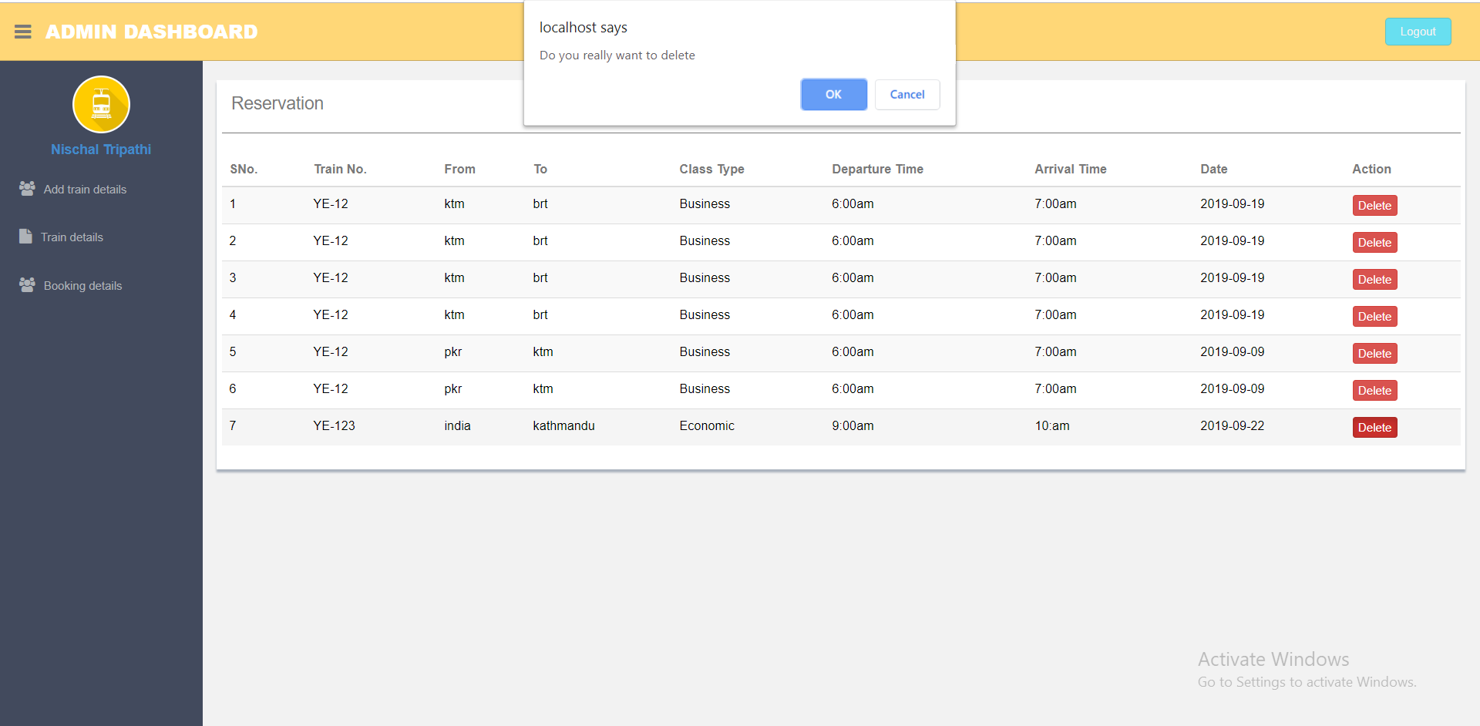

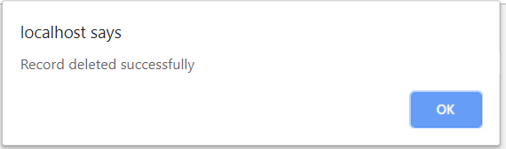

Black box testing 10: Add feedback

|  |  |  |  |  |  |
| --- | --- | --- | --- | --- | --- |
| Test Case | Description | Task | Expected Result | Actual Result | Conclusion |
| 1 | Add feedback | Fill the given details. | Feedback must be added successfully. | Feedback added successfully. | Pass |
| 2 | Form validation | Leave any attribute blank. | Error message must be displayed to the user. | Error message displayed. | Fail |

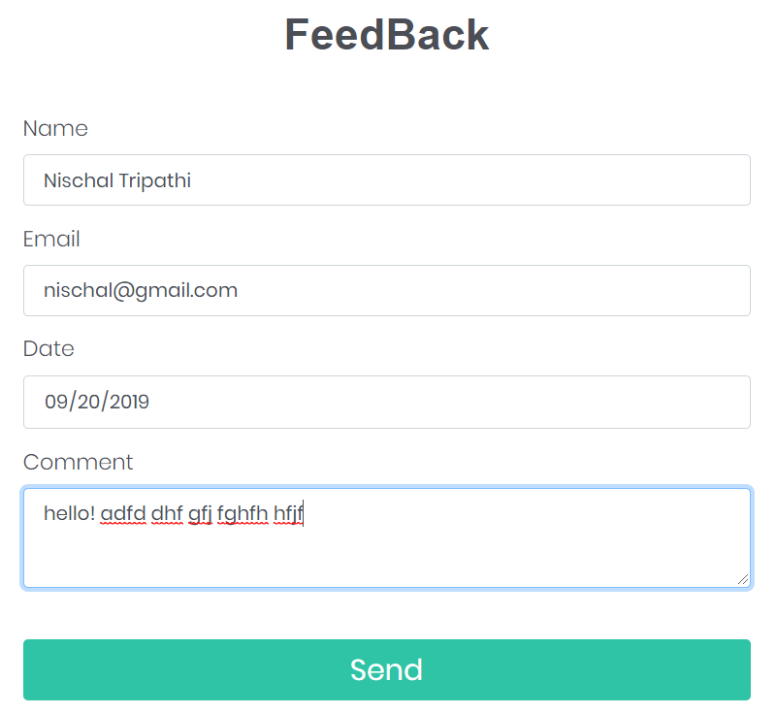

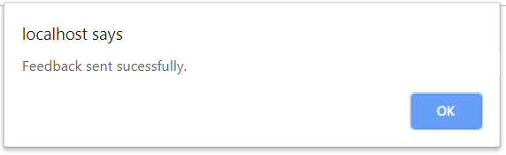

Black box testing 12: Delete feedback details

|  |  |  |  |  |  |
| --- | --- | --- | --- | --- | --- |
| Test Case | Description | Task | Expected Result | Actual Result | Conclusion |
| 1 | Delete feedback details. | Admin can select the data from table and delete it. | Feedback must be delete. | Record deleted successfully. | Pass |

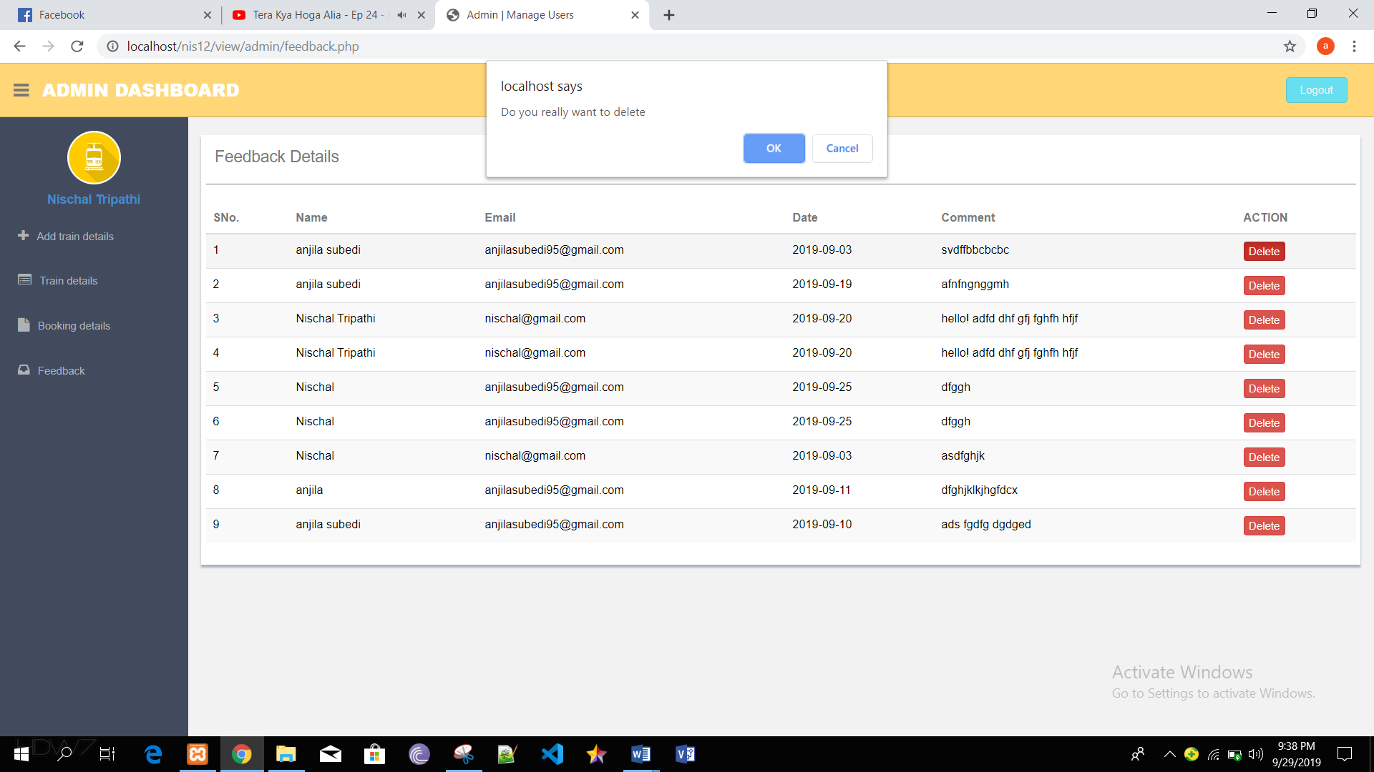

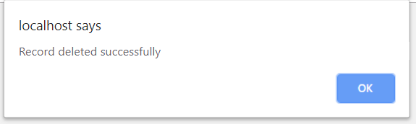

Black box testing 12: Cancel ticket

|  |  |  |  |  |  |
| --- | --- | --- | --- | --- | --- |
| Test Case | Description | Task | Expected Result | Actual Result | Conclusion |
| 1 | Cancel the booked ticket. | User can cancel the tickets. | Ticket must be canceled successfully. | Ticket cancelled successfully. | Pass |

Output:

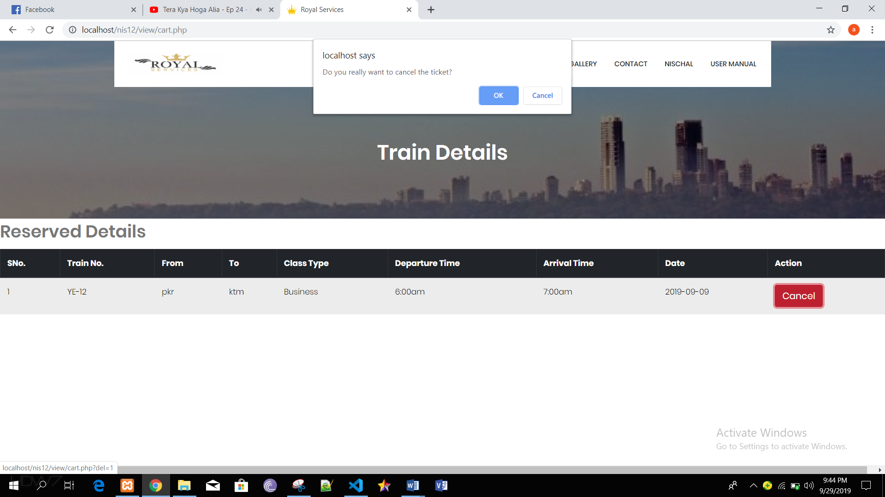

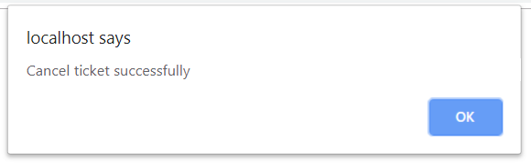

# Chapter 6: Other project issues

## 6.1 Limitation

As every system Train ticket booking system has its own limitations which are as follows,

* The users can’t talk live with the admins if they have any queries but they can message them in the contact form.
* The system is not capable of assisting visual impaired peoples.
* The senior citizens can’t claim the discounts from online booking for that they need to book on the station.
* Security is not that strong which can cause data theft.

## 6.2 Future work

In Train ticket booking system I have added many functions and also to upgrade the system we can add many functionalities in future. So, below down are the future works,

* Send notification
* This is one of the important function which a system needed it helps to send the notification to the users for there every bookings.
* Invoice generator
* This is also one of the main functions which we have to insert in our system because it makes the both parties sure about the payment.
* Confirmation of account
* The user should get the confirmation regarding their account it will help them to know that their account is successfully confirmed it will also make them feel secure.
* Visual impaired friendly
* We have to implement some features which can help the visual impaired personals to use the system this way they can also experience the system.

## 6.3 Risk management

Developing system is one of the most difficult part of information technology and as everything developing a system also has its own risks. So, risk management is an approach of identifying risk, assessing risk as well as taking step to reduce risks to an acceptable level. The risk management approaches requires certain tools, team. The risk management plan also describes how the risk management will be structuralized and will be performed on the project. (Rouse, n.d.)

For calculating process we will use two tables,

1. Likelihood table

|  |  |
| --- | --- |
| **Likelihood** | **Value** |
| Low | 1 |
| Medium | 2 |
| High | 3 |

1. Consequences table

|  |  |
| --- | --- |
| **Consequences** | **Value** |
| Very Low | 1 |
| Low | 2 |
| Medium | 3 |
| High | 4 |
| Very High | 5 |

Now for the calculation process we calculate the impacts of risks by multiplying likelihood to consequences.

|  |  |  |  |  |  |
| --- | --- | --- | --- | --- | --- |
| SN | Risks | Likelihood | Consequences | Impact | Actions |
|  | Requirements changes | 1 | 5 | 5 | Should discuss about the requirements with clients as well aa with team before developing |
|  | Untrained users | 2 | 4 | 8 | Proper training should be provided and there should be a rules to use the system before they are expert. |
|  | Natural disaster | 1 | 5 | 5 | Backup should be kept securely. Work under policies to keep the safeguard. |
|  | Data theft | 1 | 5 | 5 | Should use extra protection like firewalls and virtual private network. |
|  | Human error | 2 | 5 | 10 | Codes must be tested and also validated. |
|  | Requirement changes | 1 | 5 | 5 | Should discuss about the requirements with clients as well as with team and should get the client into agreements. |
|  | Legal risks | 1 | 3 | 3 | The projects mustn’t violate any government rules. |
|  | Unauthorized access | 2 | 5 | 10 | Passwords must be kept secure and updated time to time. |

Here are the impacts which scored more than 6 and their precautions,

1. Untrained users: It is one of the most common risk faced by many companies nowadays it is also one of the most dangerous risk because if the users of the system untrained they can corrupt the system while using it. Some of the precaution are as follows,

* Users should be given the manuals to use the system.
* Users should be trained personally by the developers.

1. Human error: Every human makes mistakes in some point so can developer and it can cause serious consequences in the developing phrase. Some of the precaution are as follows,\

* Codes should be properly tested.
* Leaders should watch the programmers personally.

1. Unauthorized access: Mostly when a company is grown there would be many competitor and they would try to get you at any cost even hackers would do the same so they could try to hack and get the access to the system. So, some of the precaution are as follows,

* Should use VPN and use encryption.
* Shouldn’t provide full access to the office staffs especially to the interns.

## 6.4 Configuration management

Configuration management is the task of tracking the changes in a system. Configuration management also helps companies to manage, organize and control the changes in the codes, files or other documents during SDLC.  (Rouse, n.d.)

Therefore, for this project also I have created various files which will be the backup files which would be updated in every 2 to 3 days before the submission and it is uploaded in GitHub. We keep the backup to ensure that if our system gets corrupted we can re-use the system from the backup.

Some of the reasons behind using configuration management are,

* It maintains the coordinate within team.
* It helps in managing project.
* Updates can be seen by any individuals in the team.

Below down is the tree structural of my project.

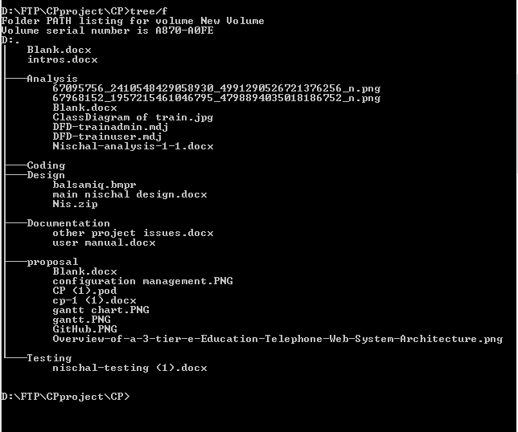

## 6.5 Other project issues

As we know each and every projects gets issues while developing a system so does we got. While developing this we had to look after the political, technical, economic and social issues. Below down are some of the project issues.

* Database can get lost
* Computer can crash while developing and if it isn’t saved the data loss may occurs.
* The system might not be fit for society every society requires and likes different designs and features.
* The system may effect political parties.
* The system may promote politics.
* The system may not be economically feasible.

## 6.6 User manual

A system user manual is an instruction which helps to use the system. As our Train ticket booking system helps the customer to get a great experience in booking the system also it will save the time of the customers while booking the tickets. Train ticket booking system also watches out for any customer who are missed out and also decreases the vacant seats ratio.  (Hlova, 2017)

In our system there are many functionalities and those are,

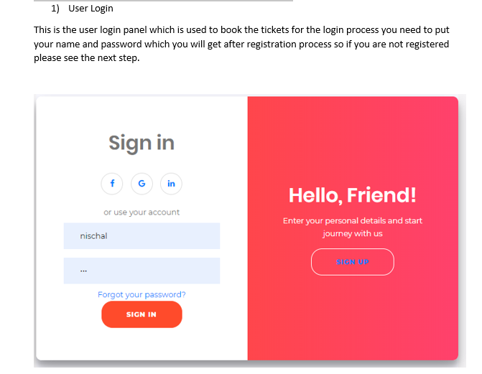

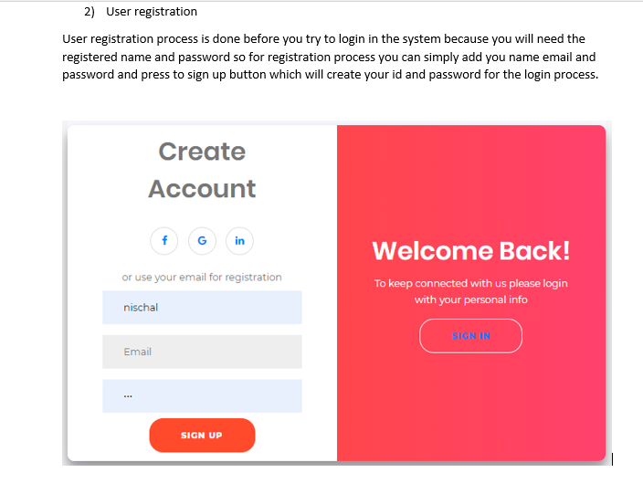

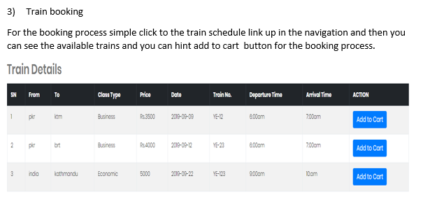

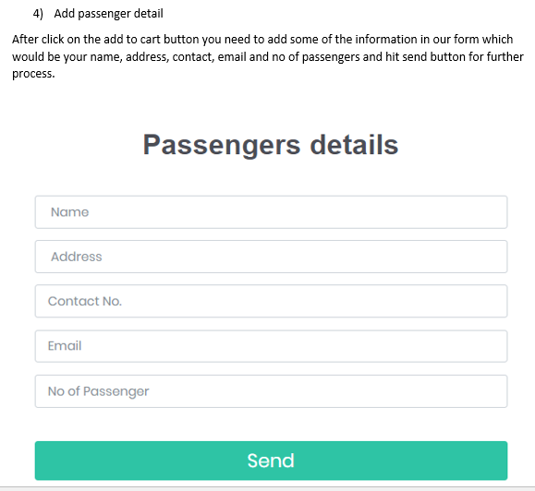

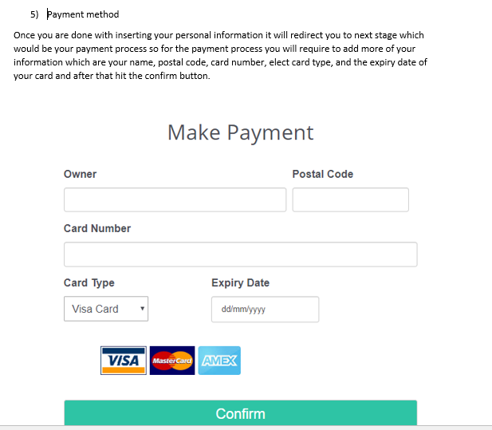

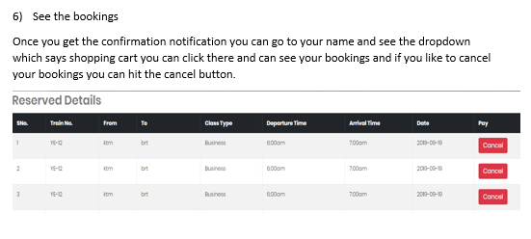

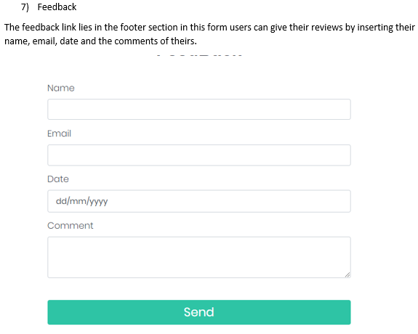

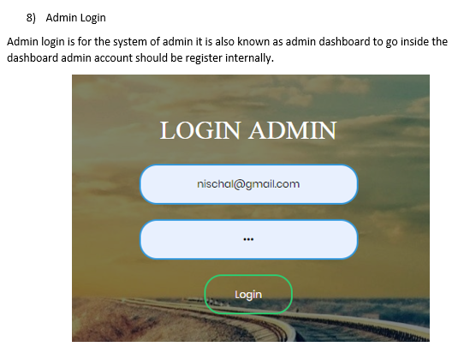

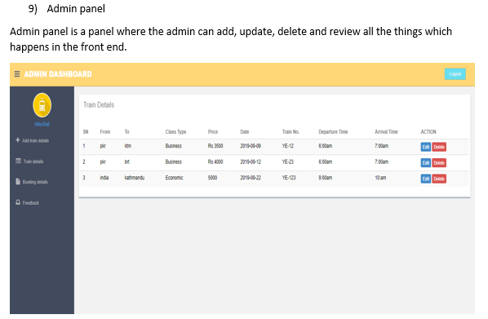

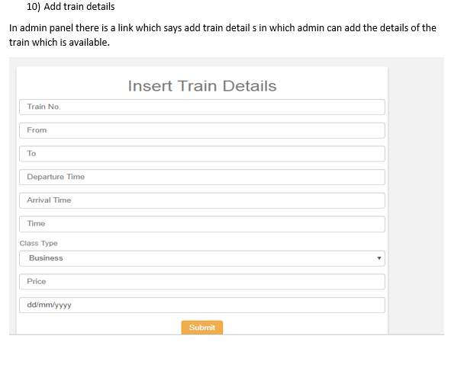

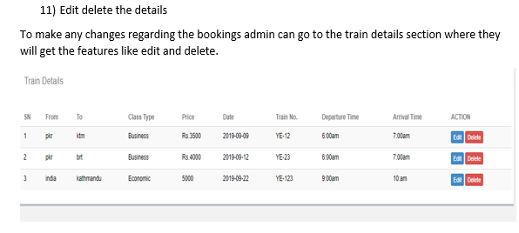

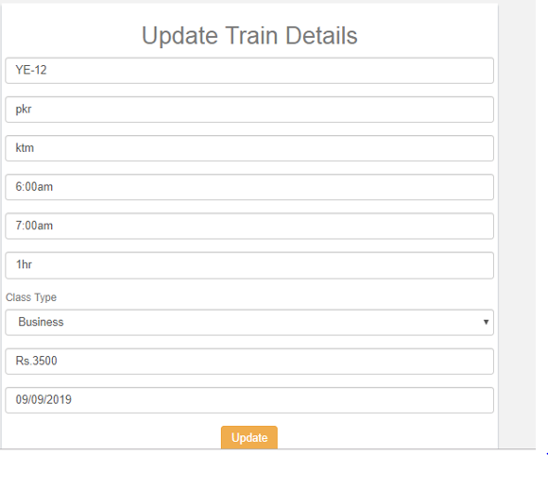

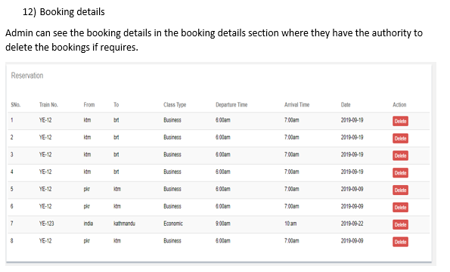

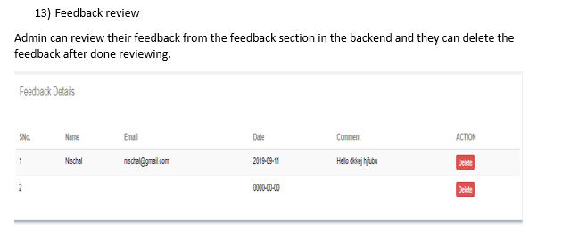

# Conclusion

Finally, the project is completed by meeting all the requirements. A complete executable website was developed. At first the task were divided into different parts and each part has its own role to play in this project completion. This project was divided into 6 parts: introduction, analysis, design, implementation or coding, testing and other project issues.

In the chapter 1, introduction of the project is discussed along with its background. The aims and objectives of this project is mentioned in this part more clearly. At this analysis phase, I have chosen hard approach methodology for which i selected Data flow diagram (DFD) to describe the whole case scenarios through the diagram. Functional and non-functional requirements are also mentioned in this phase where the requirements are prioritize using MoSCoW prioritization. For the system architecture, I have chosen 3-tier architecture. Initial class diagram is created by doing NLA of the project scenario.

The design phase was then documented which consist of dynamic and static diagram along with data dictionary and Er diagram. I have created class diagram and flow chart with proper explanation and notation in the static diagram whereas dynamic diagram consist of activity diagram and sequence diagram with justification and notation. Data dictionary is also created in the part describing all the data types required in the system. ER diagram was created using the attribute present in the data dictionary. UI modelling of the system is created using Balsamiq tool.

Next, implementation was done where I have selected PHP as source of programming language which include object oriented framework. I have done black box testing of the project in the testing phase. In the next phase, some of the issues of the project are mentioned. Limitation of the project is described in this phase. I have also analyse some of the risk that may occur while completing this project. User manual of the project is clearly mentioned in this chapter.

Overall, train ticket booking system is completed. For this project I have used some tools like: -Visual Paradigm, MySQL, Balsamiq, Star UML etc.

# References

Anon., 2011. *guru99.* [Online]   
Available at: https://www.guru99.com/system-testing.html  
[Accessed 17 10 2019].

Anon., n.d. *dlsweb.* [Online]   
Available at: https://www.dlsweb.rmit.edu.au/Toolbox/knowmang/content/gathering_data/information_gathering_methods.htm#top  
[Accessed 5 10 2019].

Anon., n.d. *guru99.* [Online]   
Available at: https://www.guru99.com/uml-class-diagram.html  
[Accessed 9 10 2019].

Anon., n.d. *guru99.* [Online]   
Available at: https://www.guru99.com/what-is-php-first-php-program.html  
[Accessed 15 10 2019].

Anon., n.d. *jinfonet.* [Online]   
Available at: https://www.jinfonet.com/resources/bi-defined/3-tier-architecture-complete-overview/  
[Accessed 8 19 2019].

Anon., n.d. *smartdraw.* [Online]   
Available at: https://www.smartdraw.com/entity-relationship-diagram/  
[Accessed 29 9 2019].

Anon., n.d. *techopedia.* [Online]   
Available at: https://www.techopedia.com/definition/27490/sequence-diagram-uml  
[Accessed 21 9 2019].

Anon., n.d. *visual-paradigm.* [Online]   
Available at: https://www.visual-paradigm.com/guide/uml-unified-modeling-language/what-is-use-case-diagram/  
[Accessed 05 10 2019].

Carey, J. & Carlson, B., 2002. *informit.* [Online]   
Available at: http://www.informit.com/articles/article.aspx?p=27123  
[Accessed 15 10 2019].

Garbade, D. M. J., 2018. *becominghuman.* [Online]   
Available at: https://becominghuman.ai/a-simple-introduction-to-natural-language-processing-ea66a1747b32  
[Accessed 8 10 2019].

Hlova, M., 2017. *stepshot.* [Online]   
Available at: https://stepshot.net/a-user-manual-or-user-guide-how-to-name-a-document-with-instructions/  
[Accessed 18 10 2019].

Jain, A., n.d. *geeksforgeeks.* [Online]   
Available at: https://www.geeksforgeeks.org/unified-modeling-language-uml-activity-diagrams/  
[Accessed 21 9 2019].

KENTON, W., 2019. *investopedia.* [Online]   
Available at: https://www.investopedia.com/terms/f/feasibility-study.asp  
[Accessed 6 10 2019].

Riuse, M., 2019. *searchsoftwarequality.* [Online]   
Available at: https://searchsoftwarequality.techtarget.com/definition/software-requirements-specification  
[Accessed 6 10 2019].

Rouse, . M. ., n.d. *searchcompliance.* [Online]   
Available at: https://searchcompliance.techtarget.com/definition/risk-management  
[Accessed 27 9 2019].

Rouse, M., n.d. *searchitoperations.techtarget.* [Online]   
Available at: https://searchitoperations.techtarget.com/definition/configuration-management-CM  
[Accessed 8 10 2019].

tutorialspoint, n.d. *tutorialspoint.* [Online]   
Available at: https://www.tutorialspoint.com/system_analysis_and_design/system_analysis_and_design_overview.htm  
[Accessed 5 10 2019].